1) Easy

Using CI/CD tool GitHub actions deploy a static web site on AWS S3. And website should be expose publicly

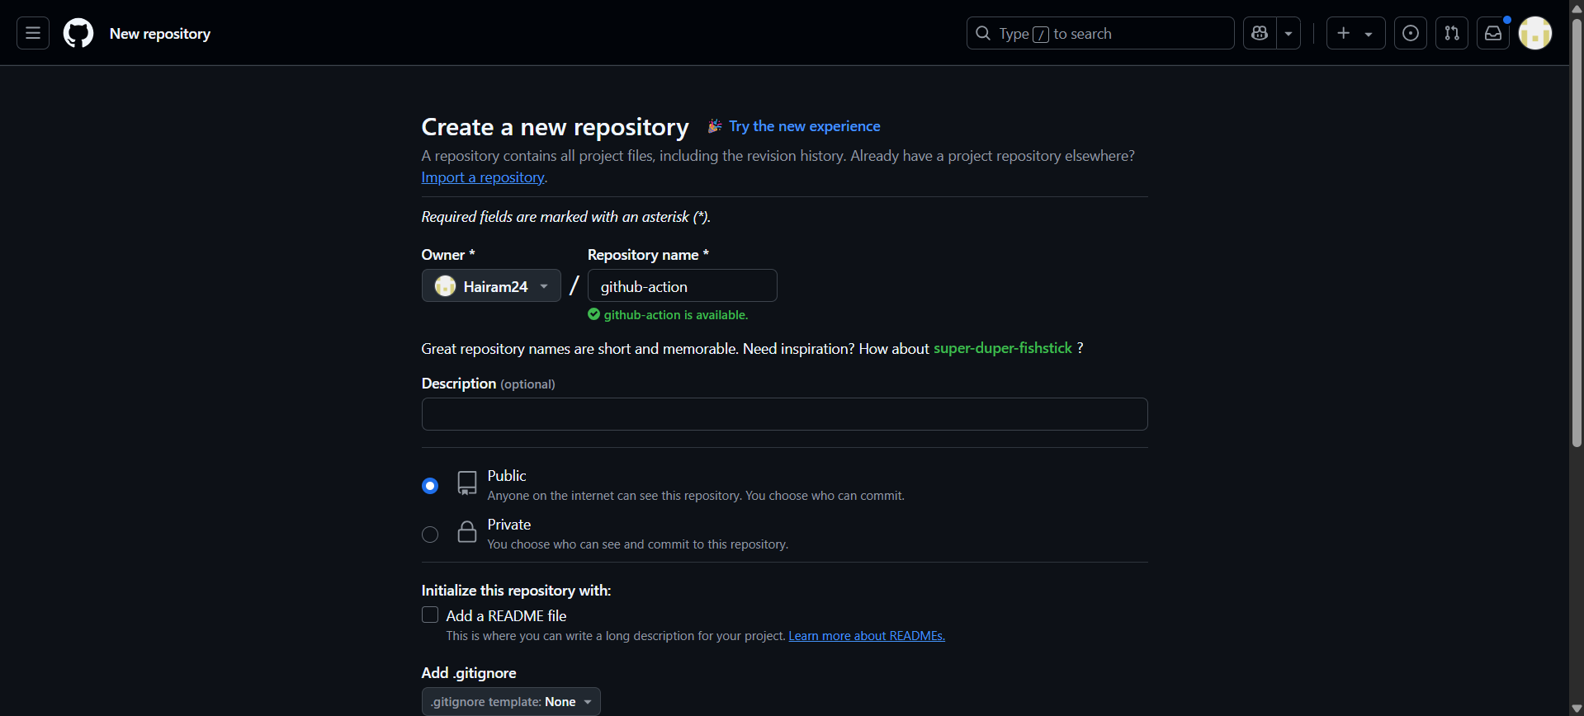

New public repo is created.

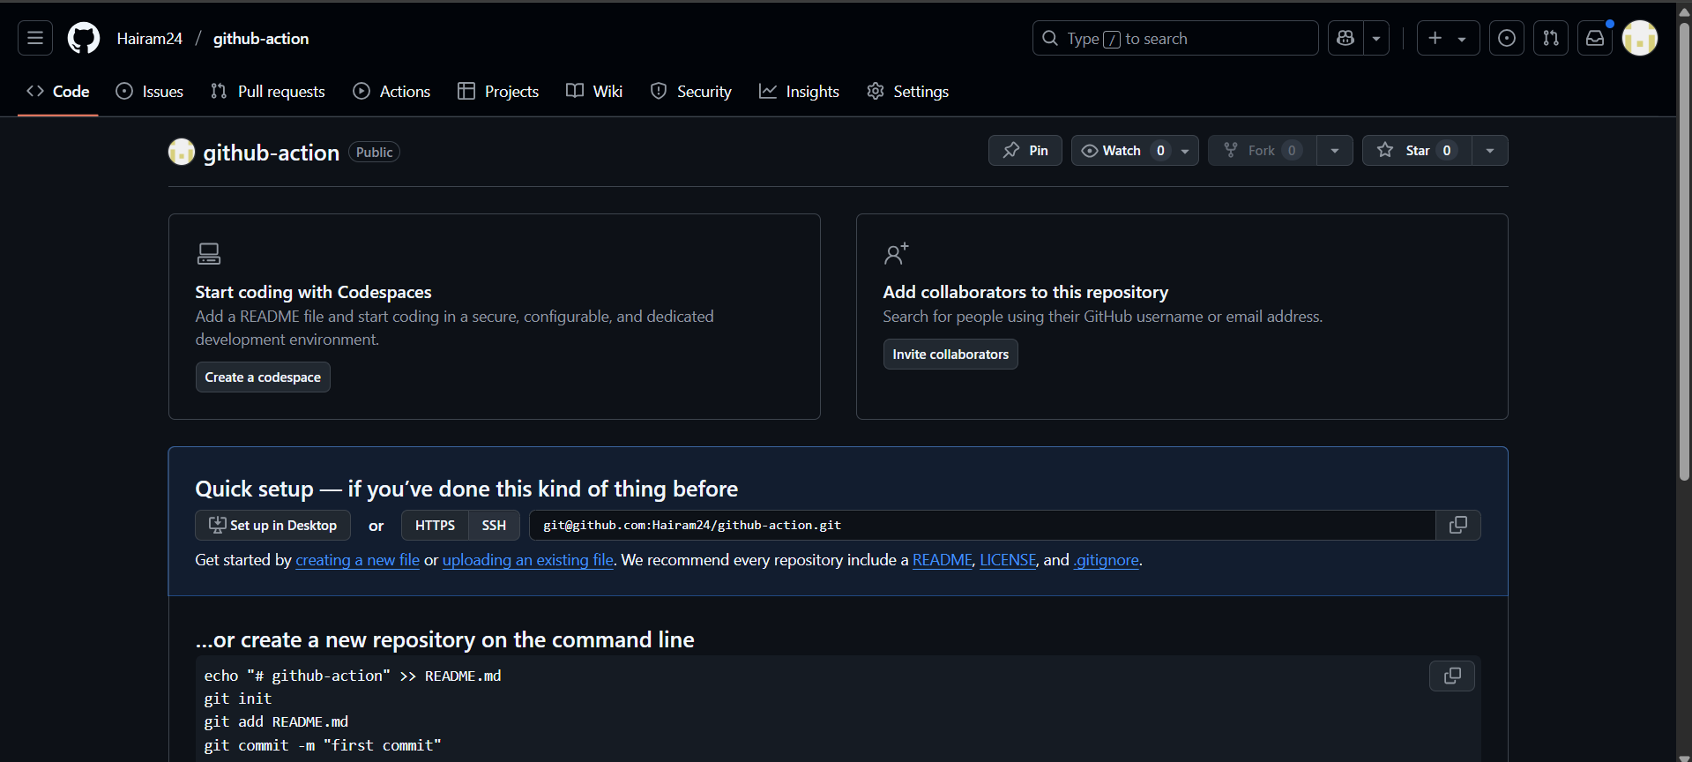

Repository successfully created.

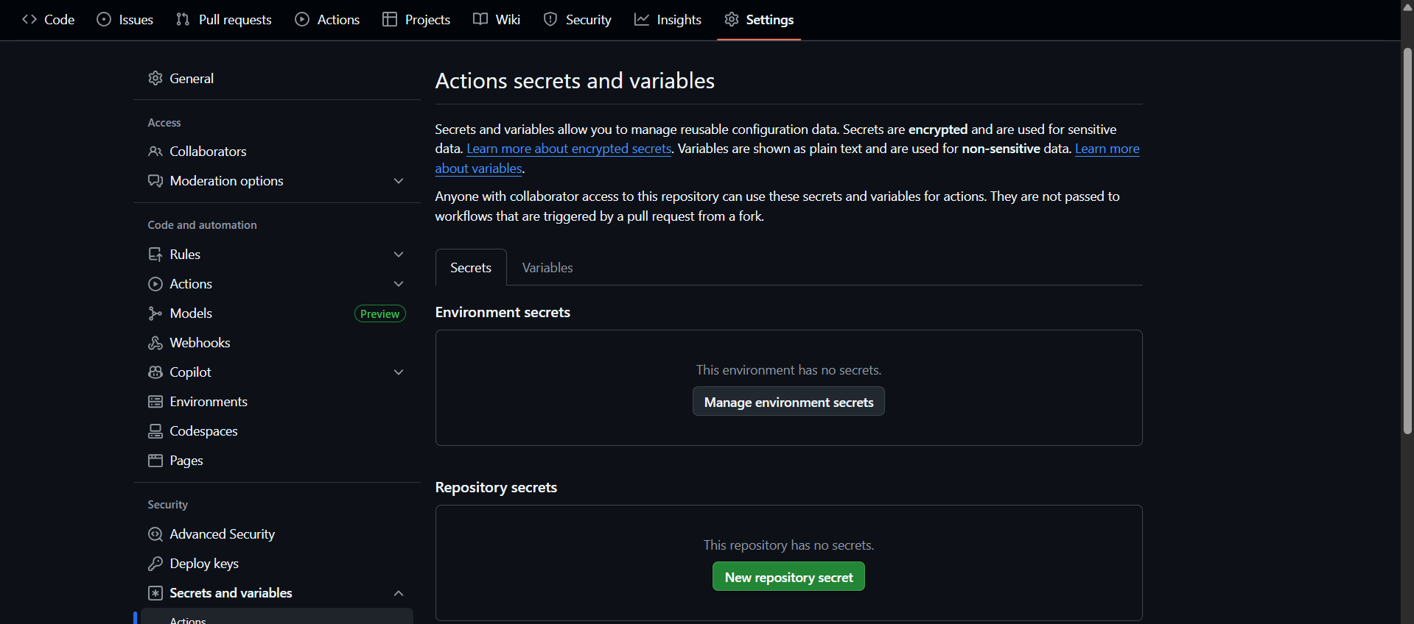

To add keys > secrets and variables> actions.

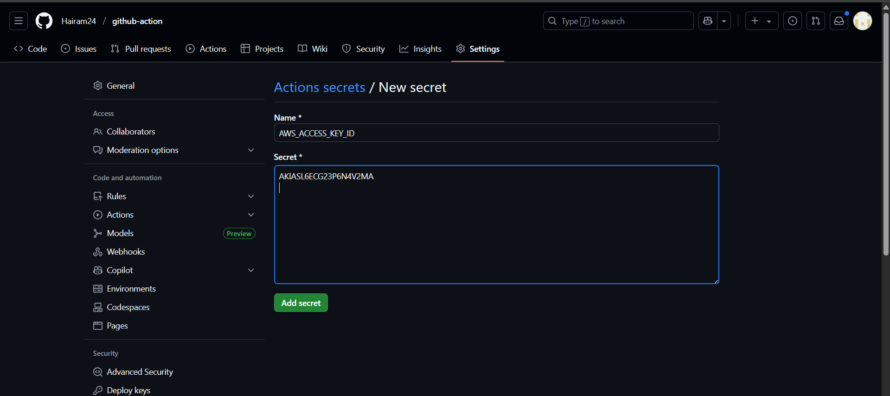

Added the aws_acces_key

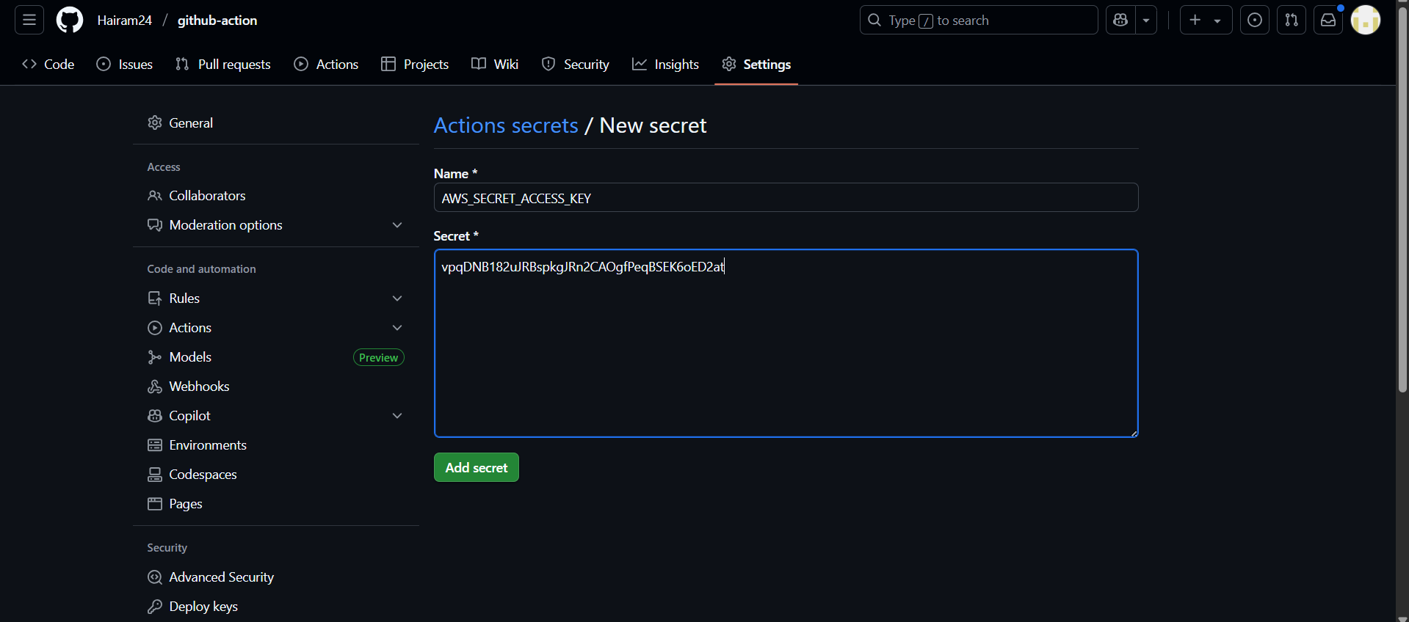

Added the aws_secret_access_key.

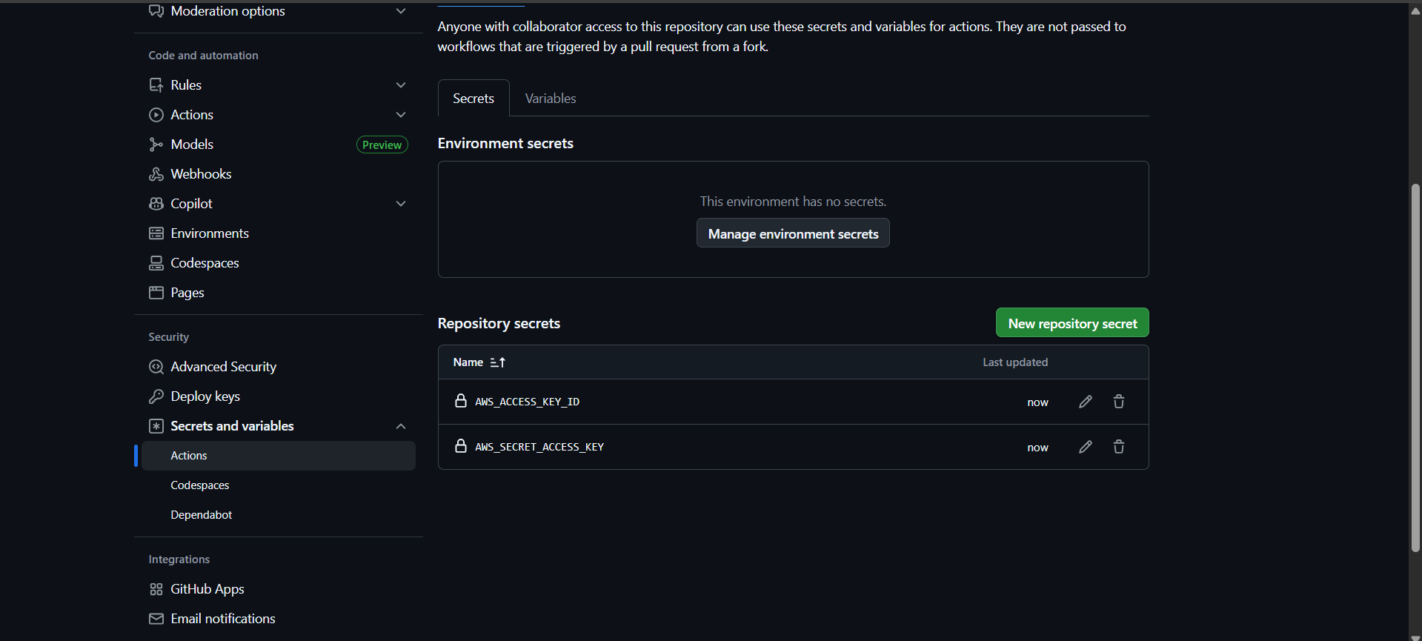

Both keys are added.

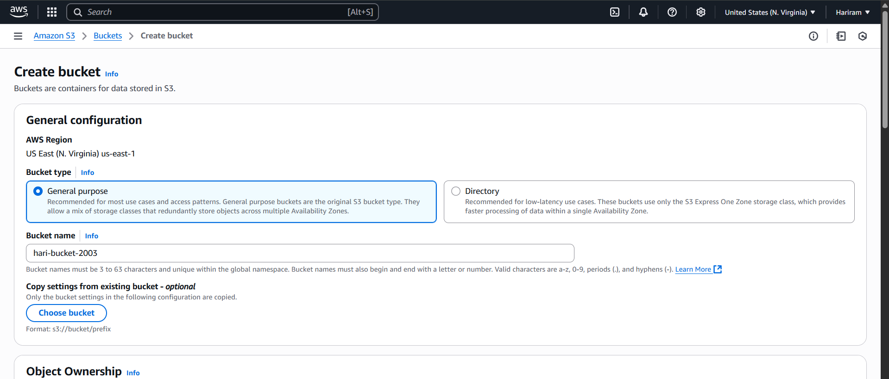

New S3 bucket is created .

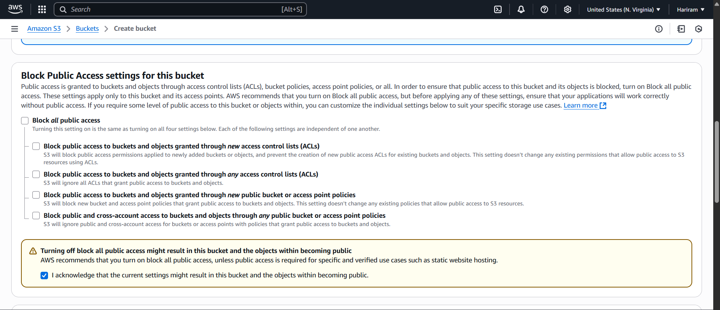

Block public access is disables.

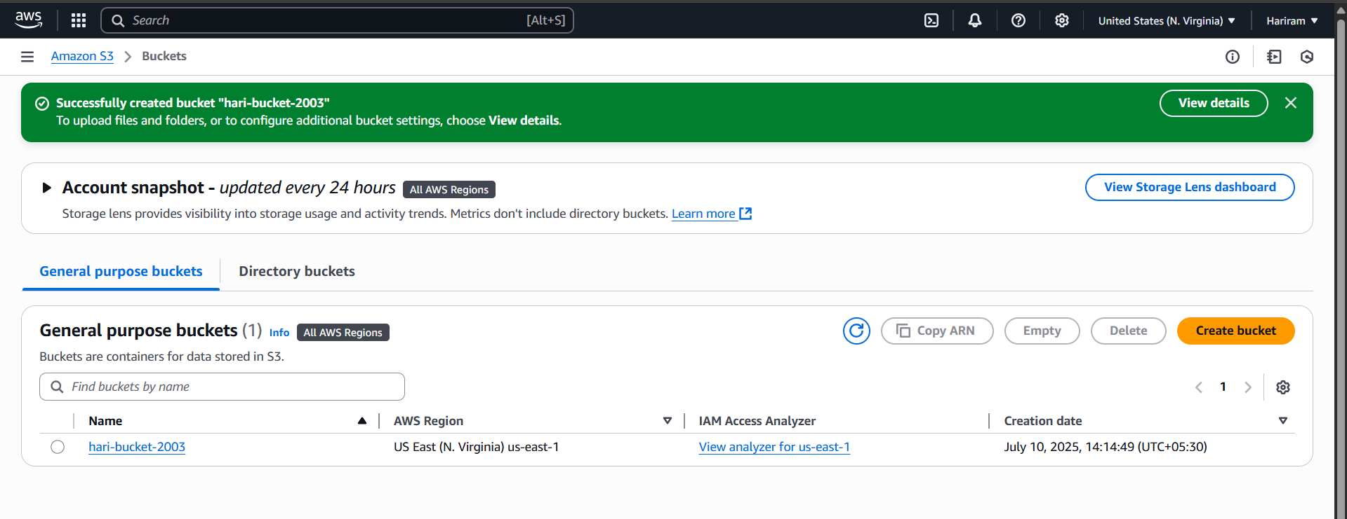

S3 bucket is created.

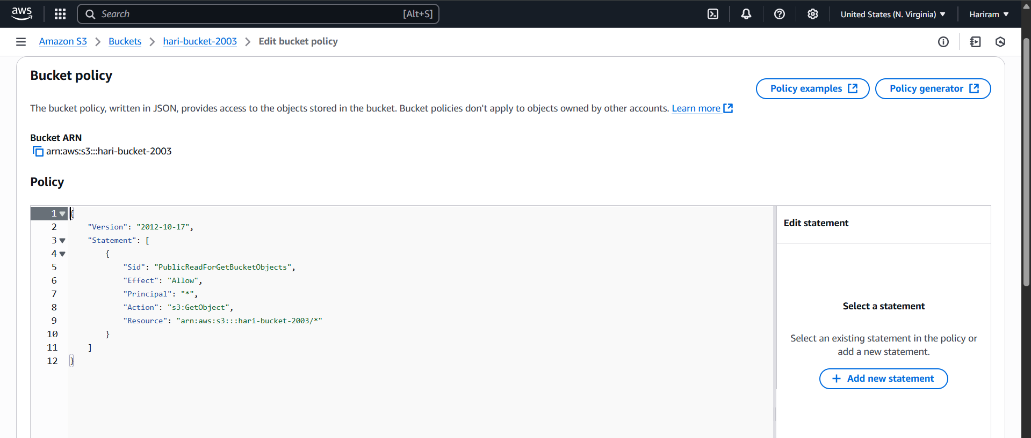

New bucket policy is added.

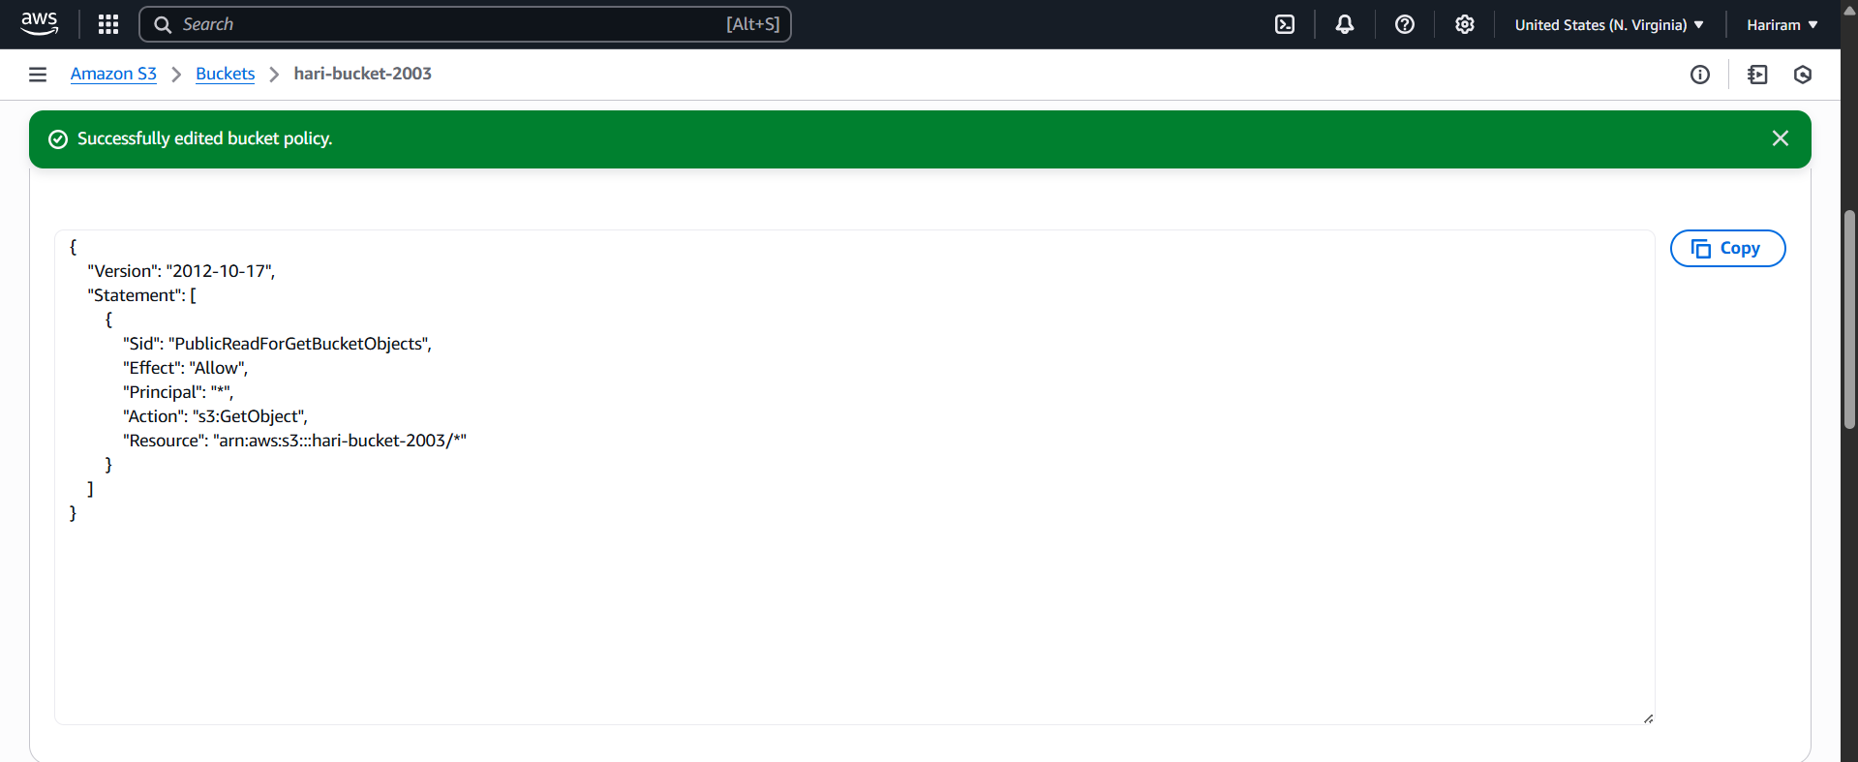

Bucket policy is added successfully.

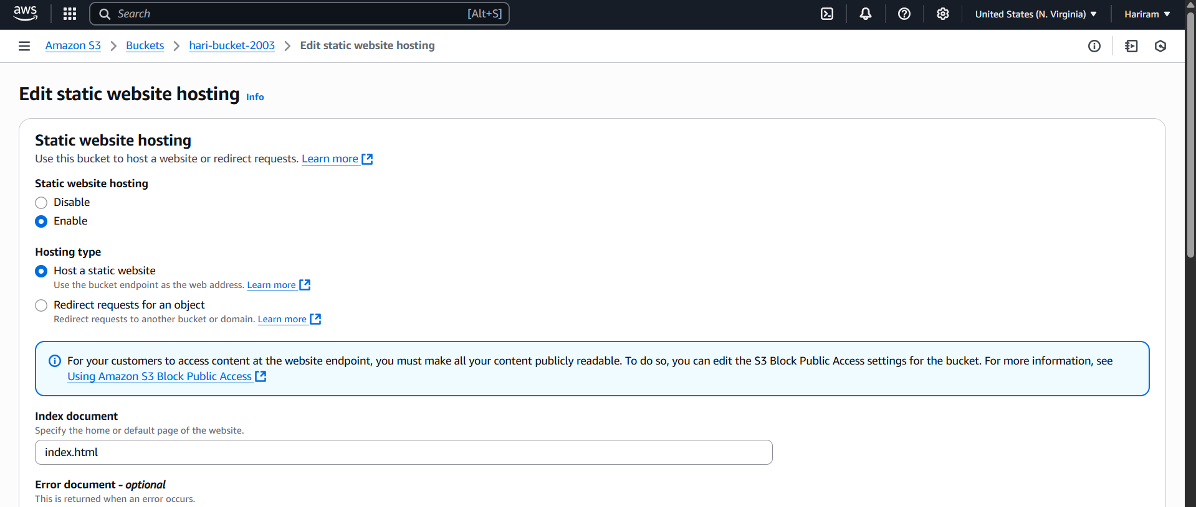

In s3 bucket , statis we hosting is enabled and index.html is added.

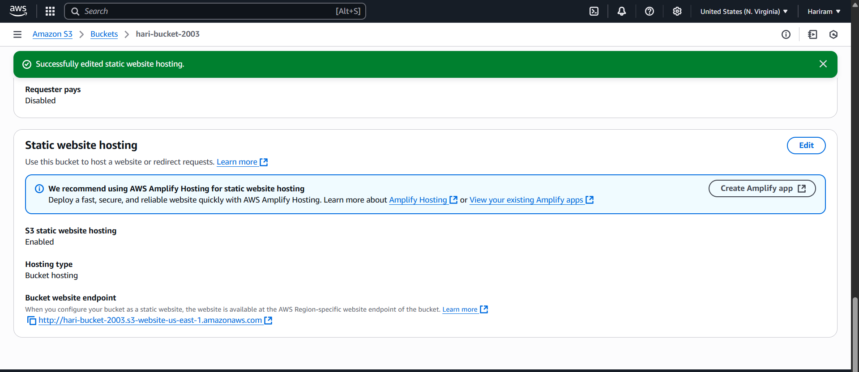

Static web hosting is enabled successfully.

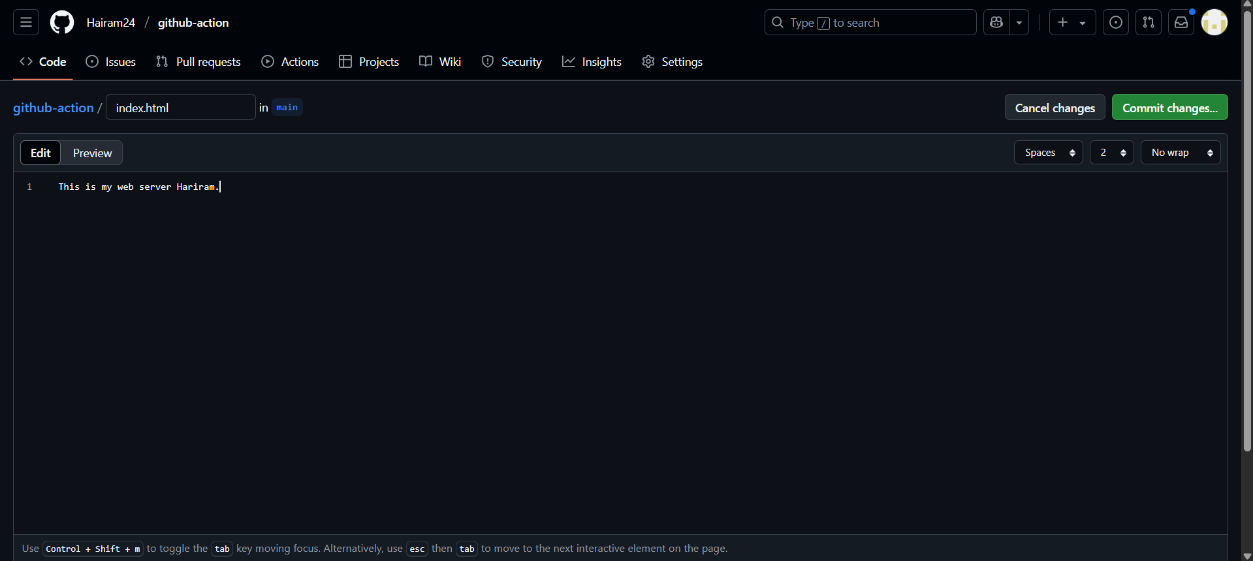

In the repo index.html file is created.

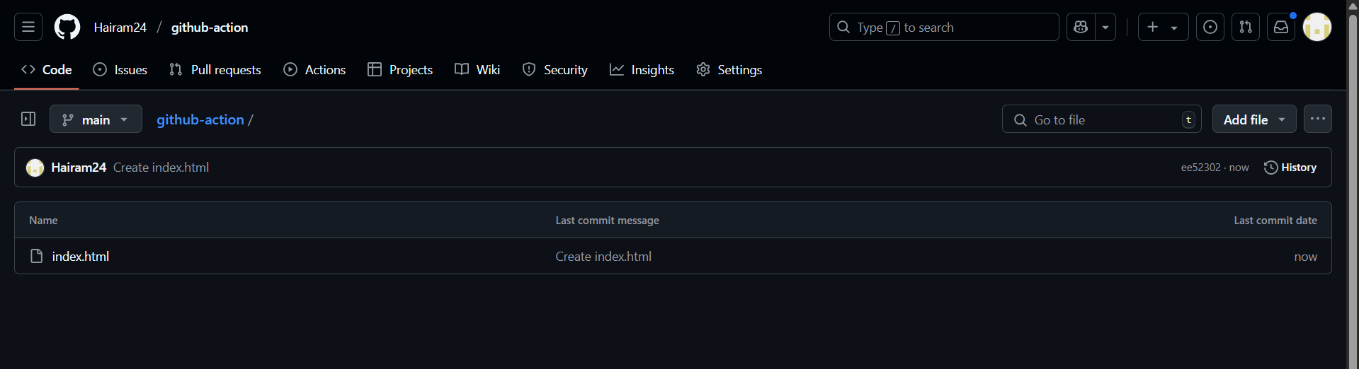

Index.html is added successfully.

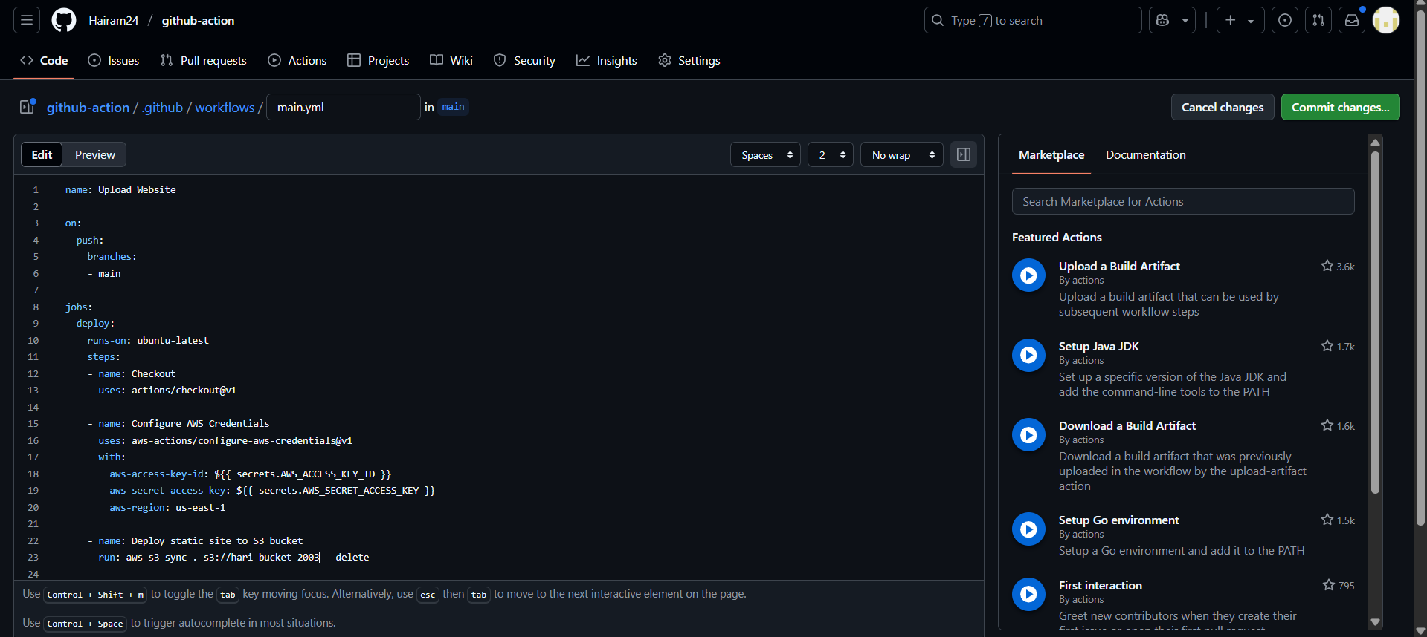

Main.yaml is added with my bucket name.

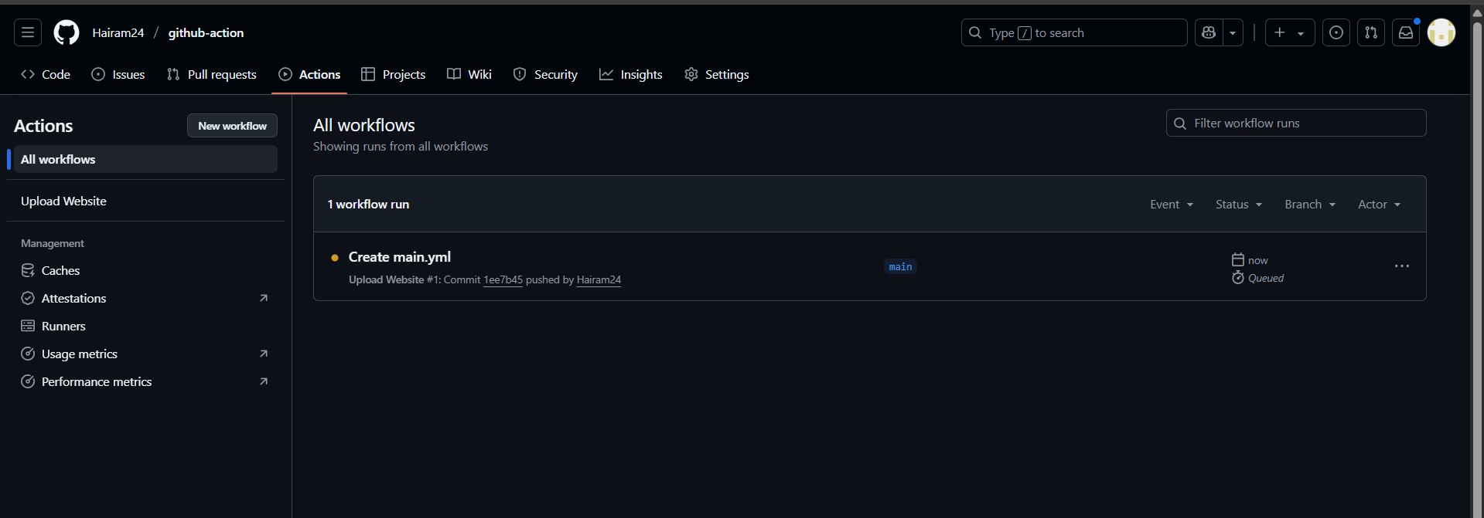

Yaml file is getting executed in the actions.

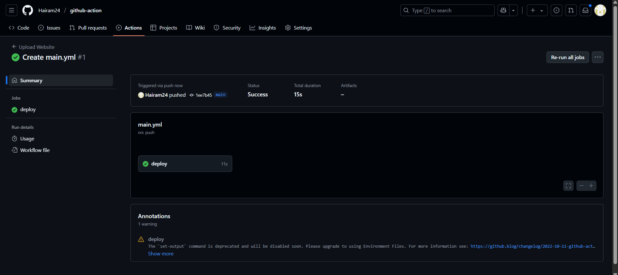

Statis website is deployed.

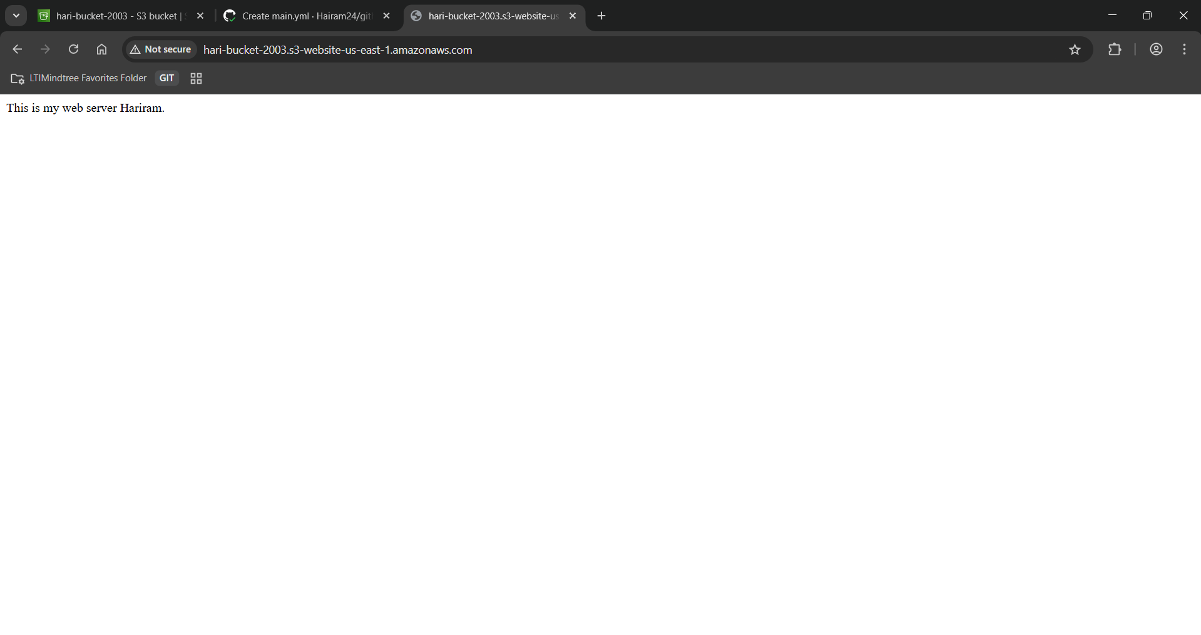

To view the website past the static web hosting link in the browser.

Static website is hosted successfully using s3 bucket and allowed publically.

2) Medium

Deploy a web application in the kubernetes pod. And create a replica set. In any case load is going to increase on your replica set. increase the number of replica of the pods

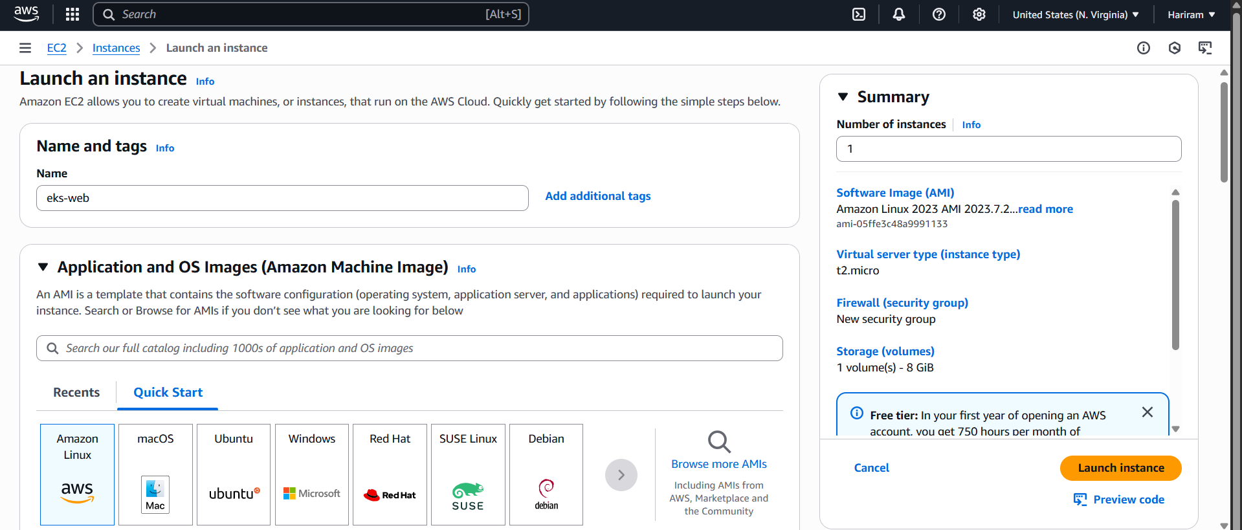

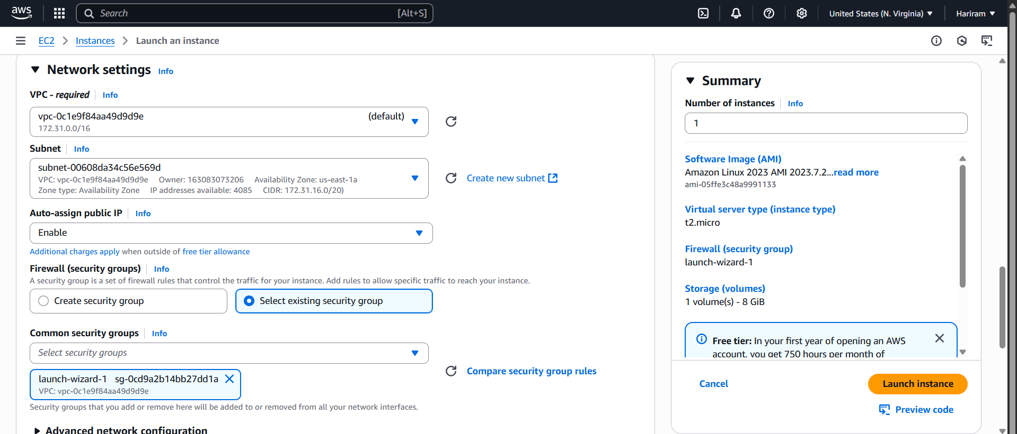

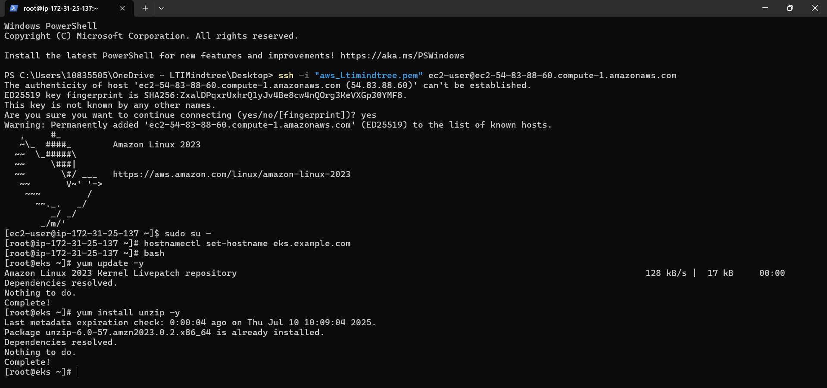

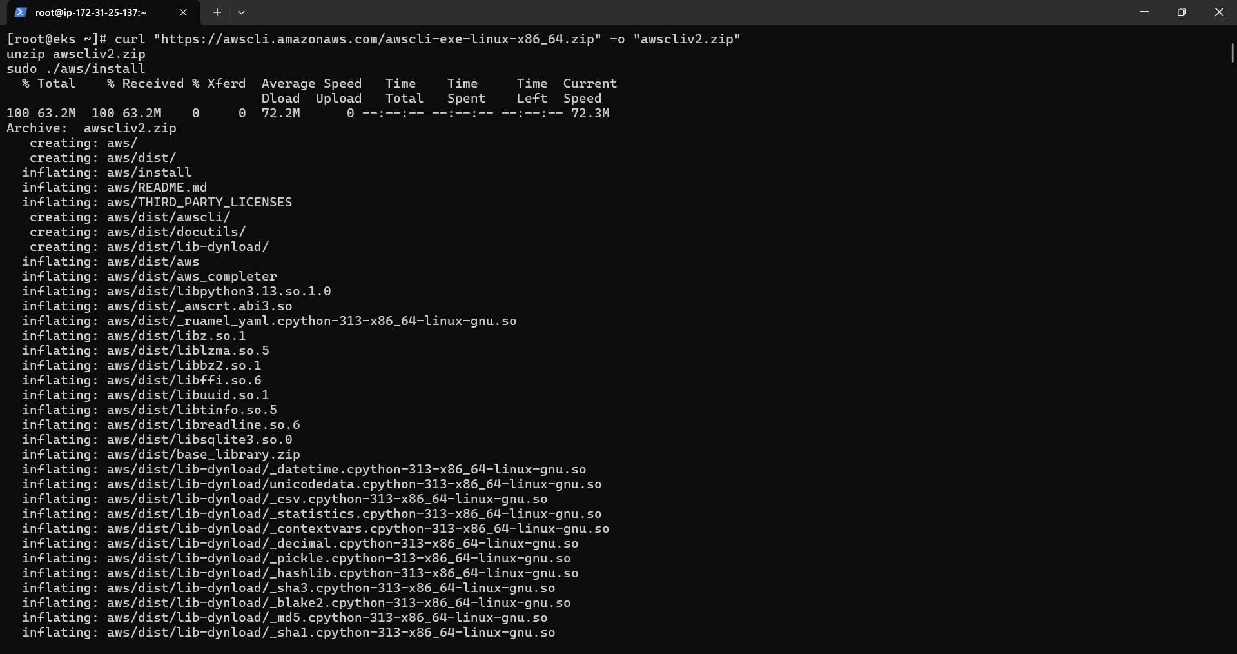

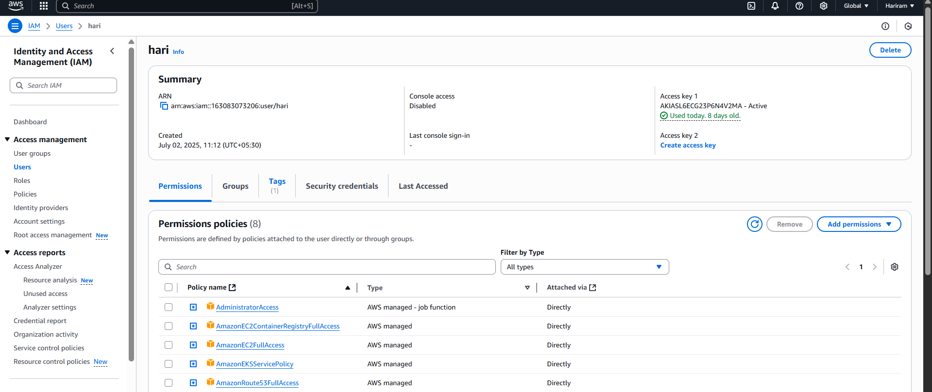



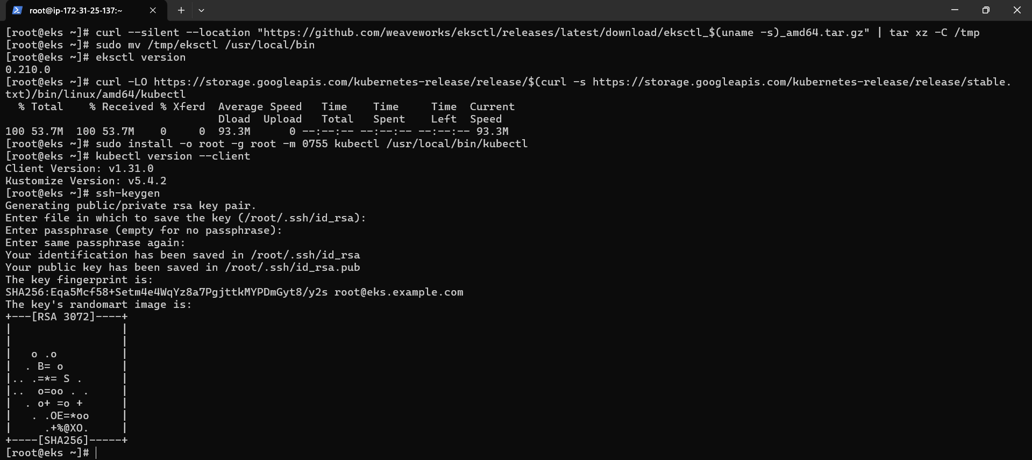

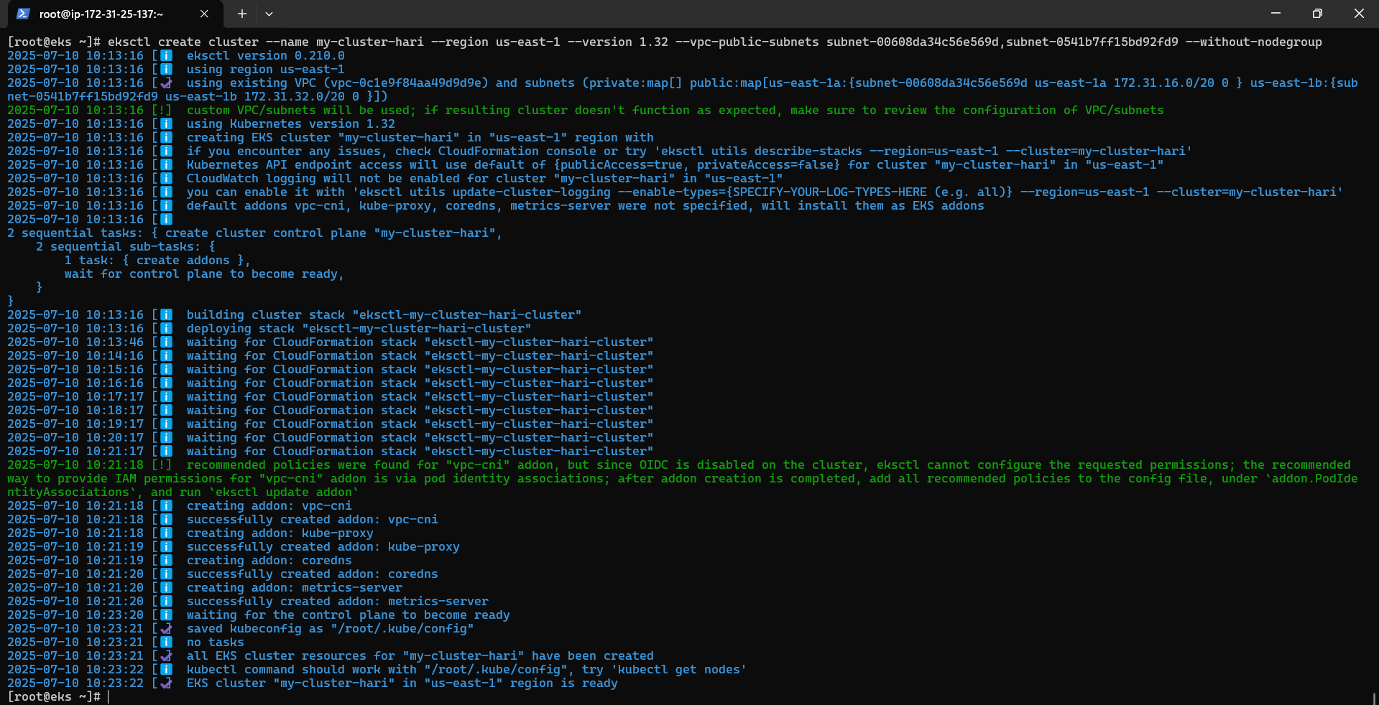

Cluster is created.

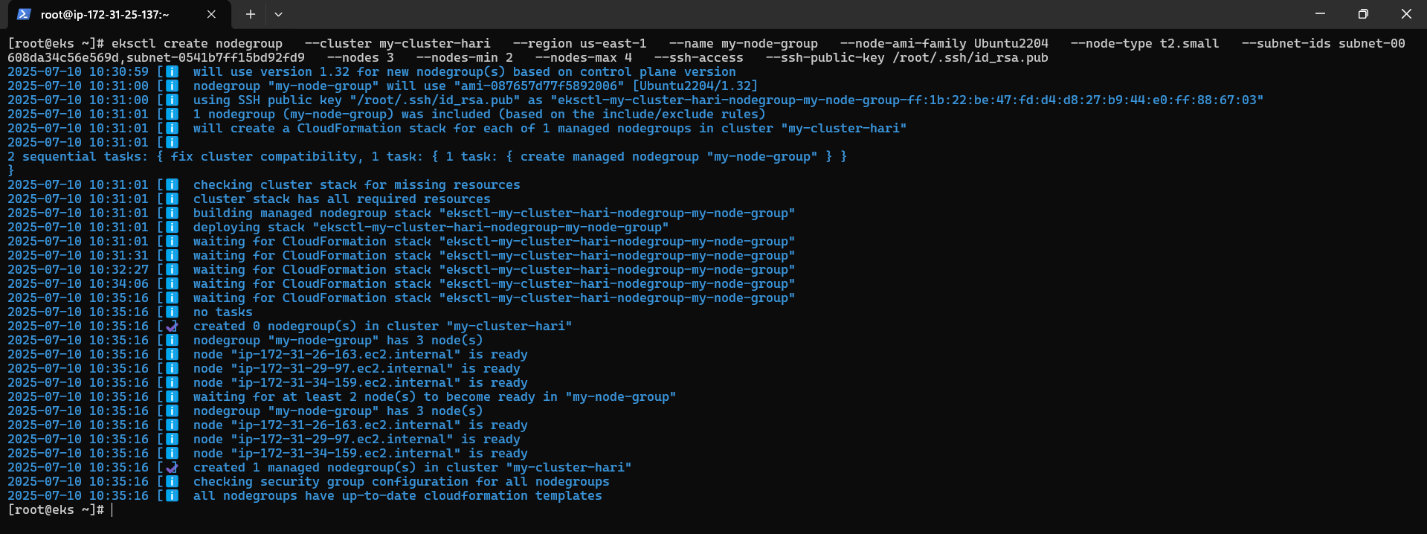

Node group is created.

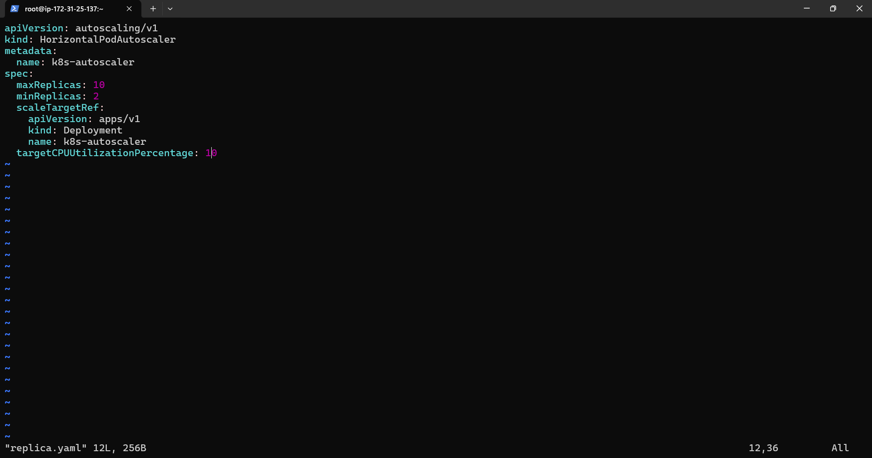

Replica is automated based on load.

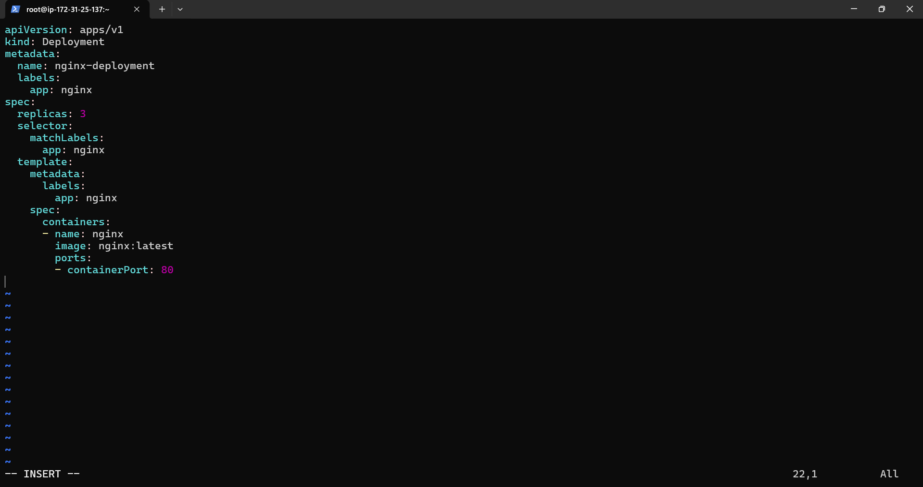

Nginx is deployed in yaml.

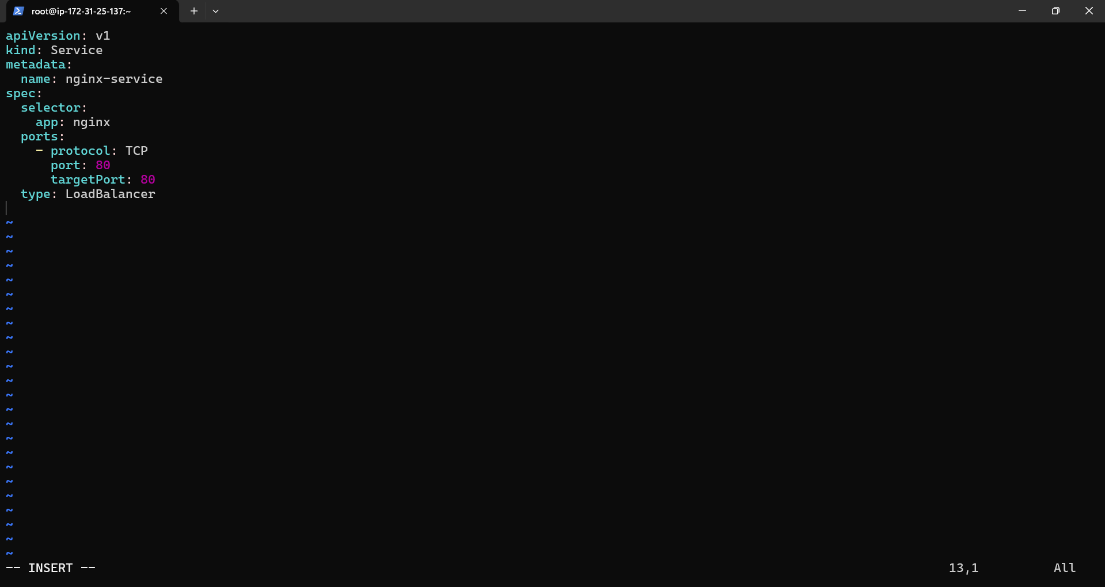

Service.yaml file is added.



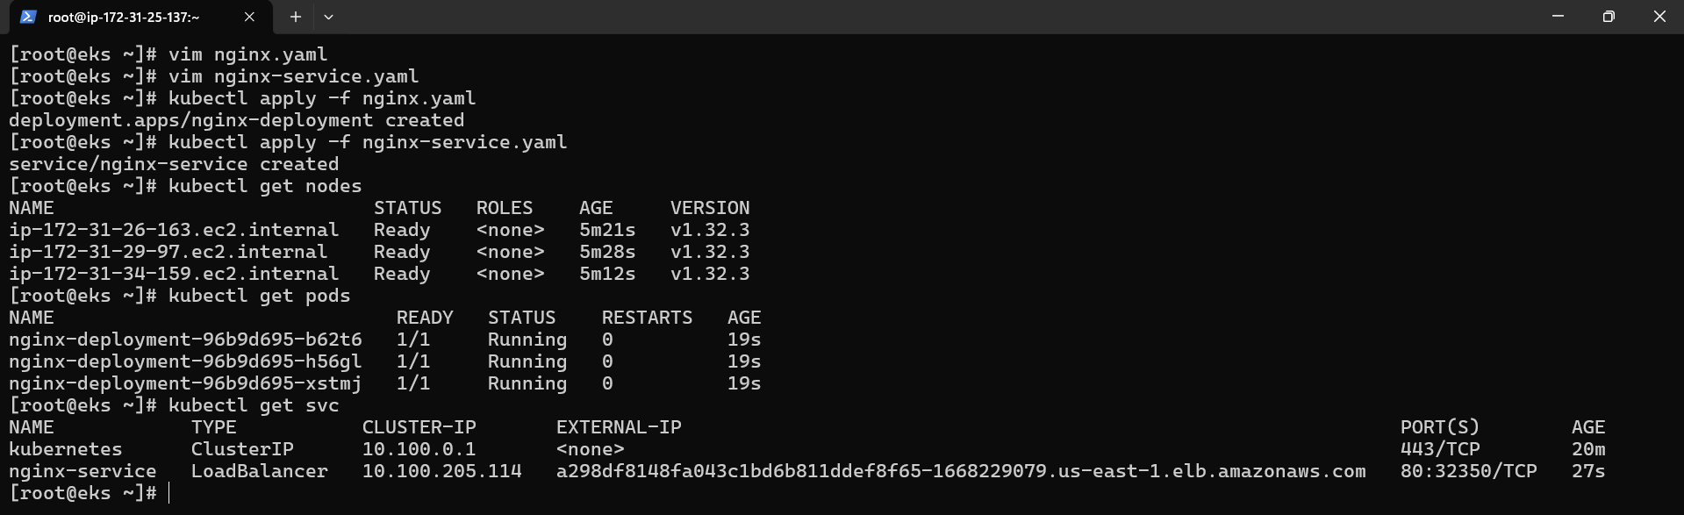

Pods are created successfully and external ip is taken.

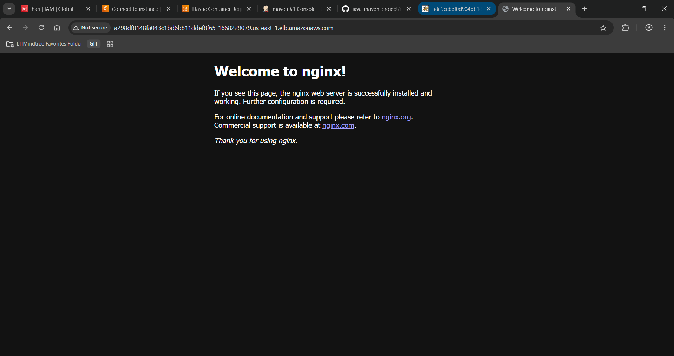

Nginx web app is deployed in the kubernetes pod and based on the load replica set will be dynamically added and deleted.

3) Easy-1

Using configuration management tool Ansible create multiple users and confirm on your manage host.

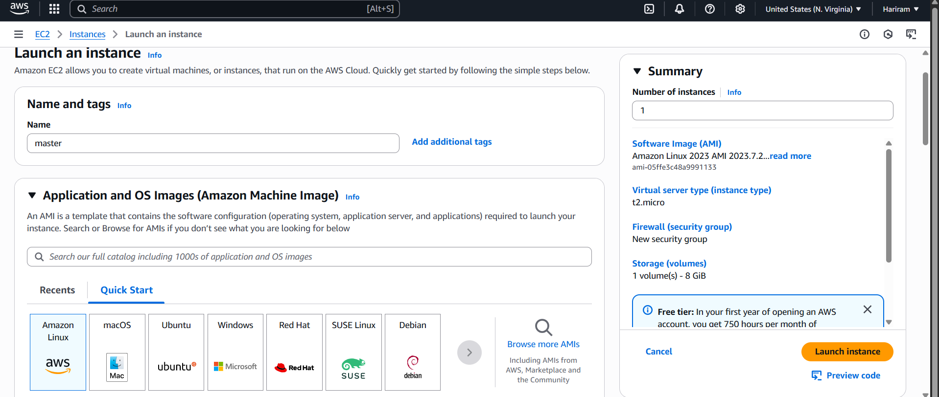

Master instance is created.

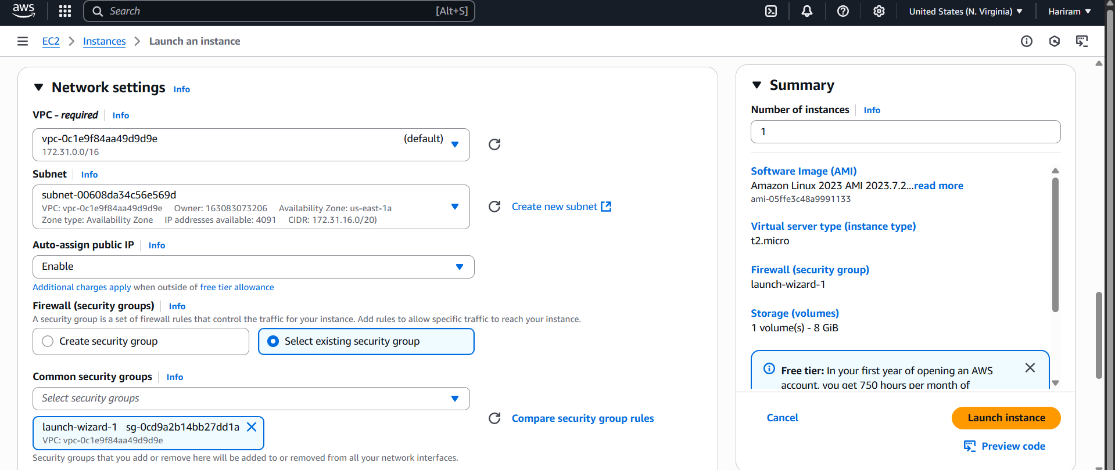

Existing key pair is selected and existing security group is selected.

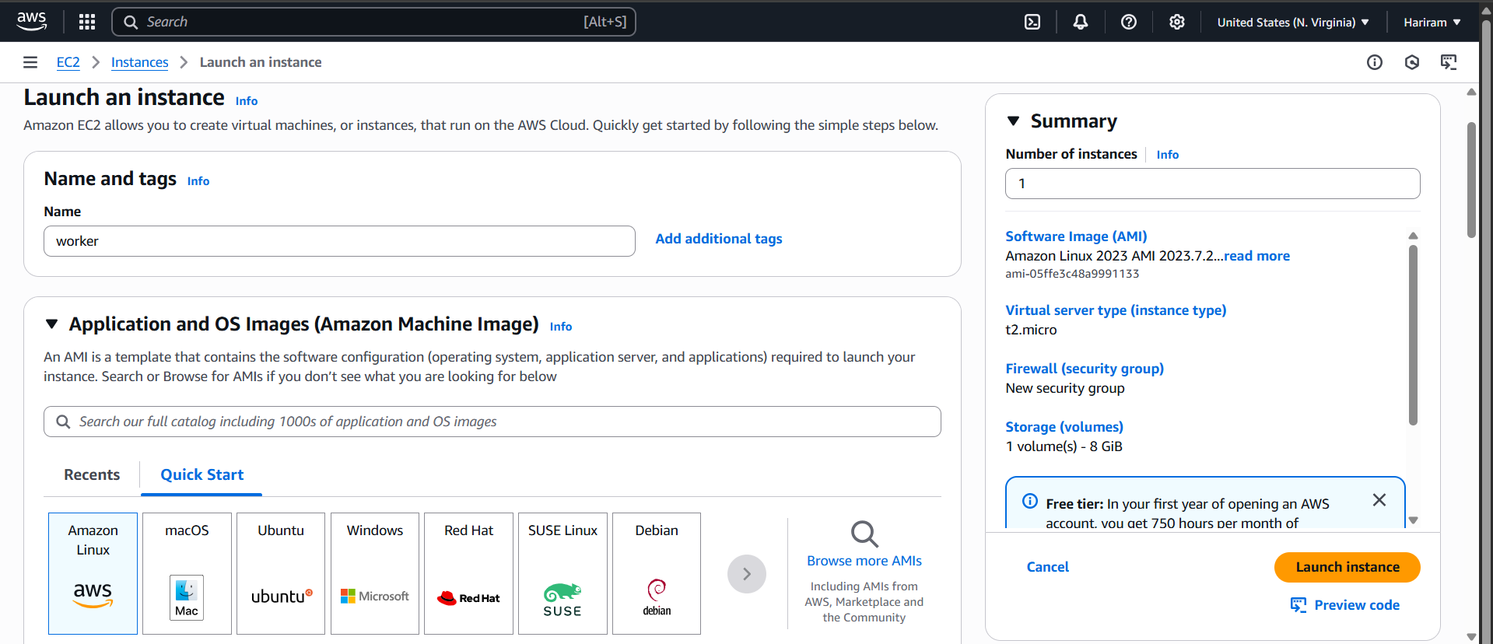

Worker node instance is created.

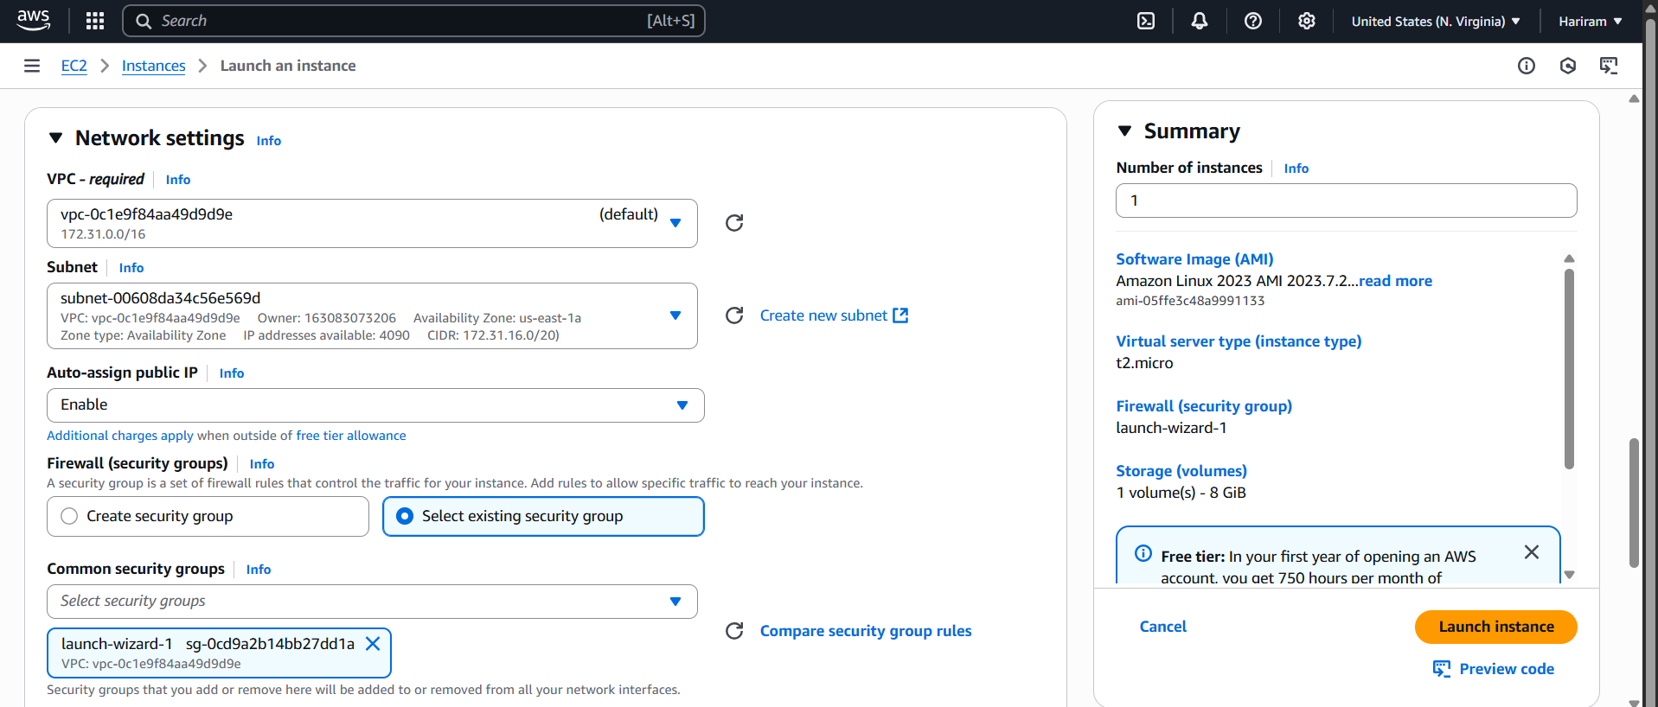

Existing key pair is selected and existing security group is selected.

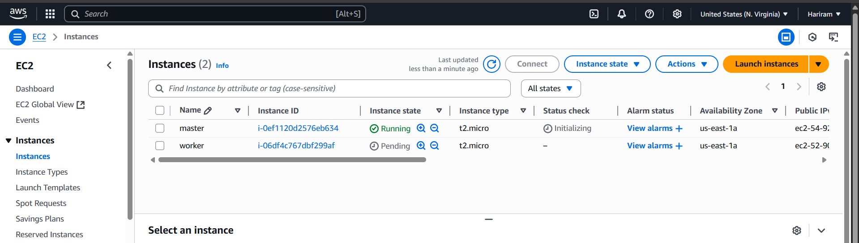

Instances are created successfully.

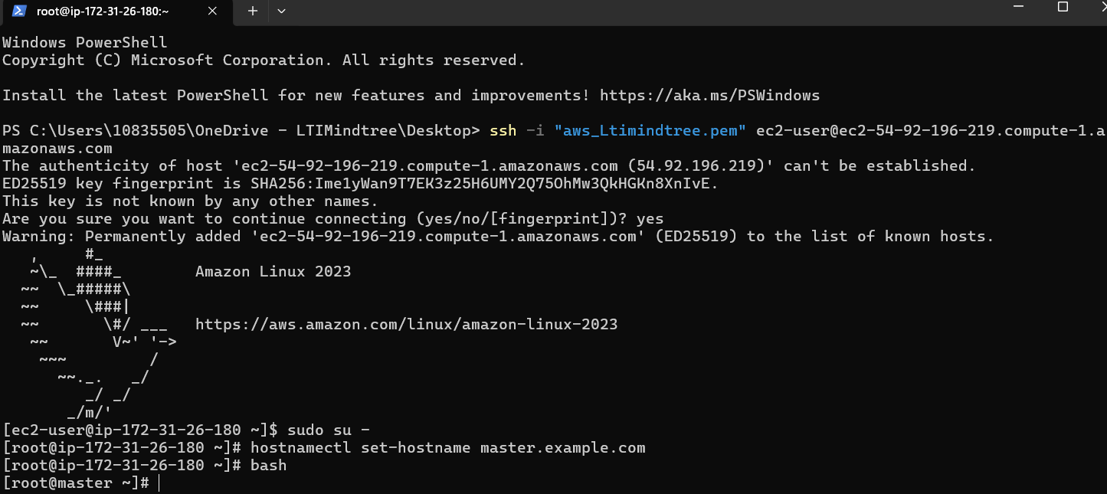

Master node is ready.

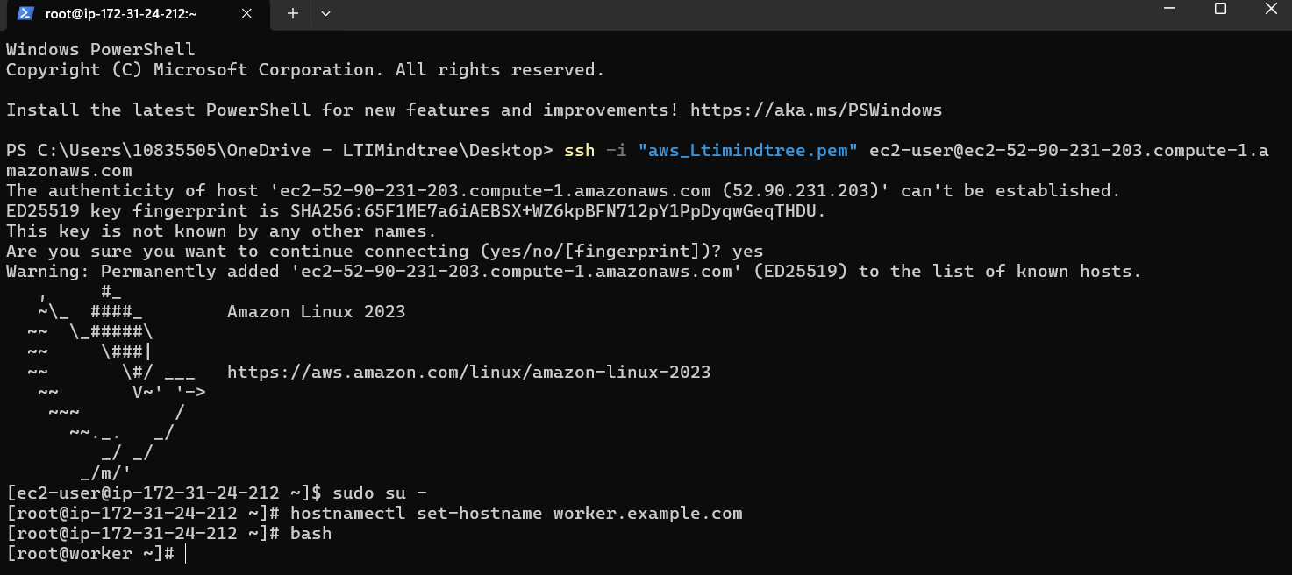

Worker node is ready.

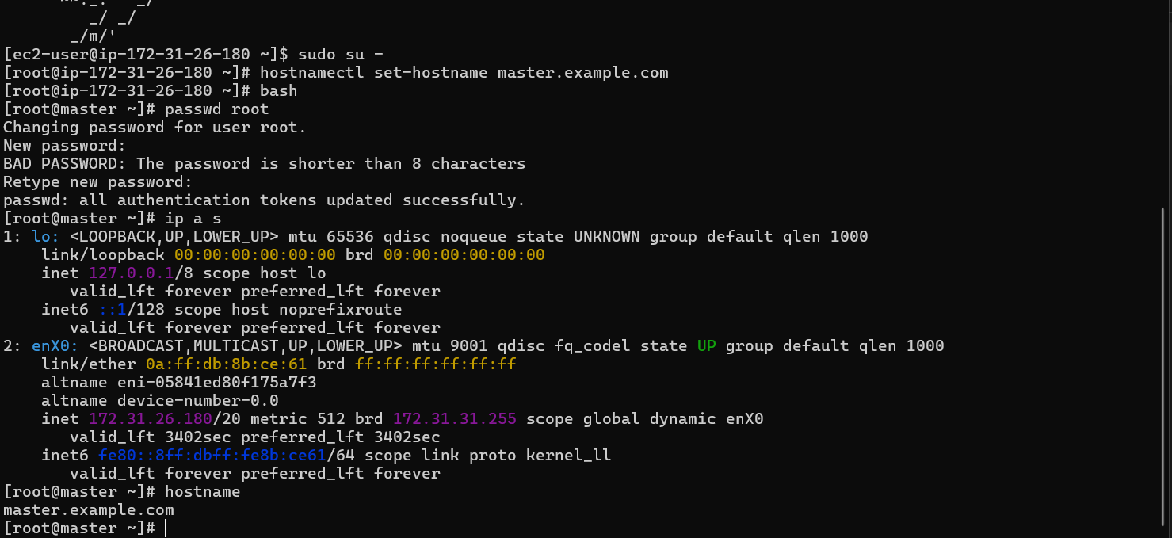

Ip and hostname of master is taken.

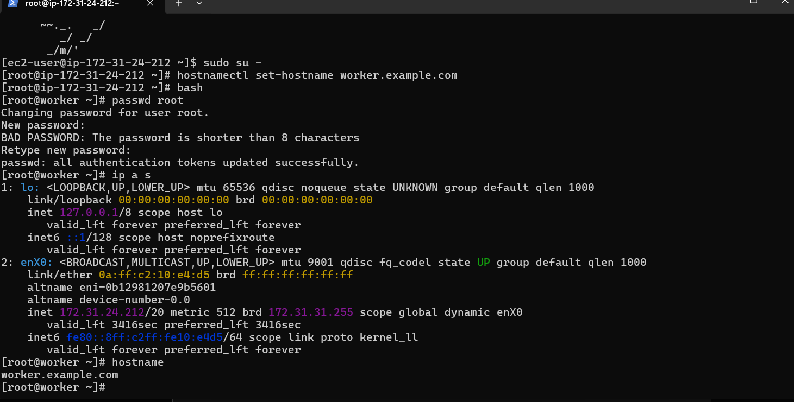

Ip and hostname of worker is taken.

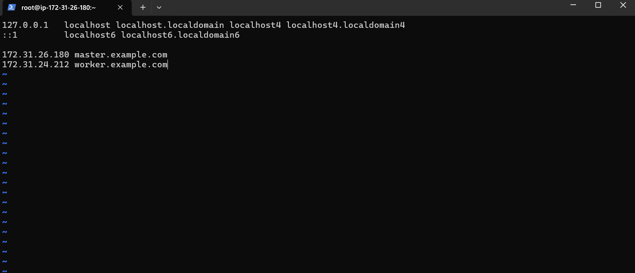



Both machine ip and hostnames are shared.

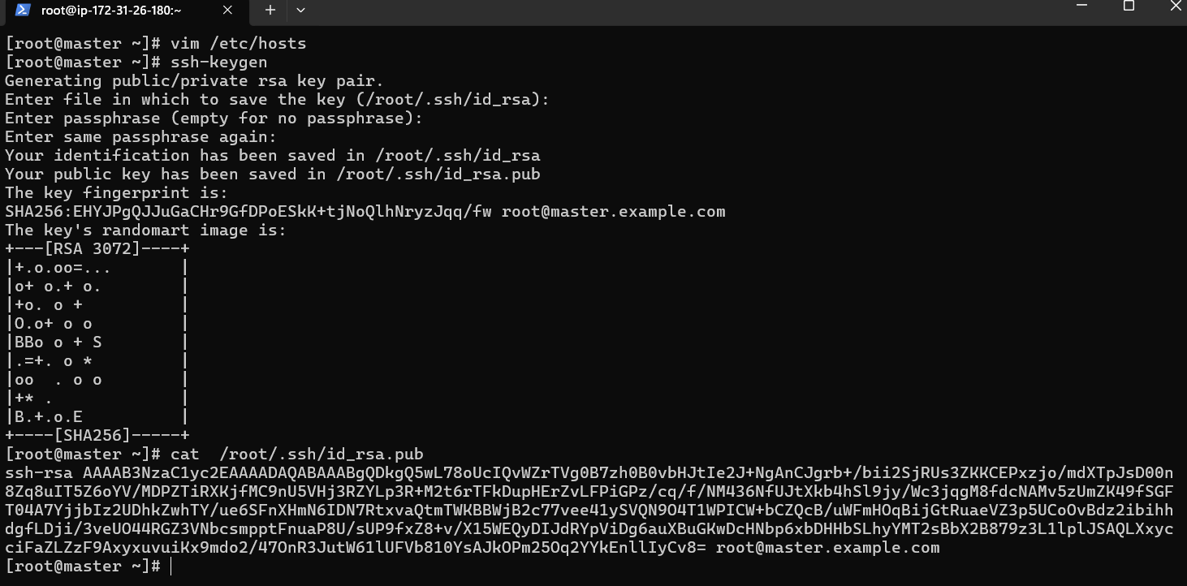

Ssh-keygen is done and pub key is copied.

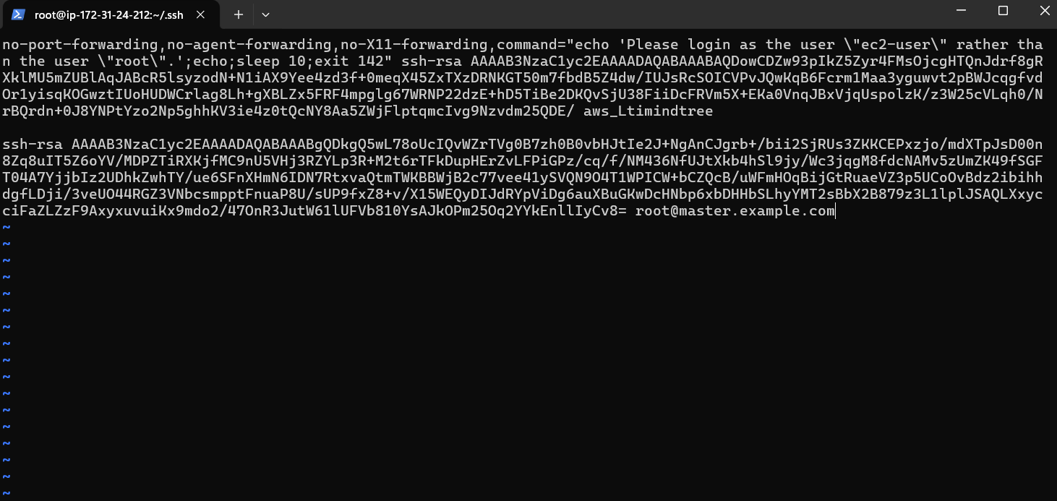

Pasted the pub key in worker node.

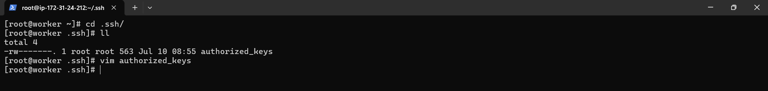

Pasted successfully.

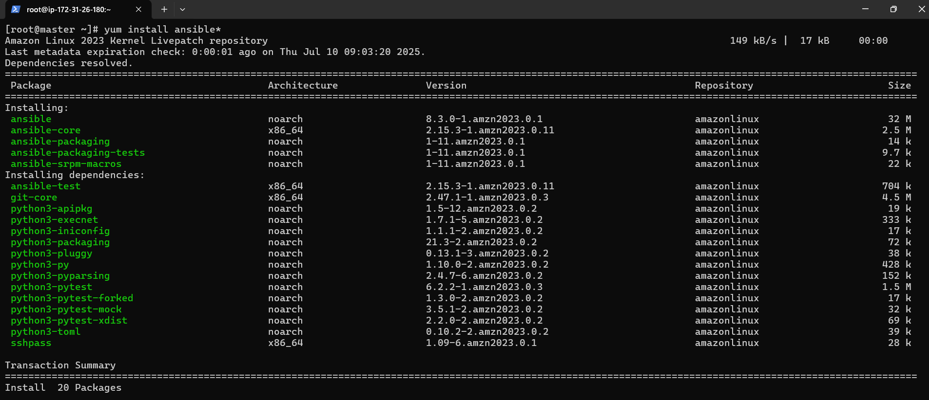

Ansible is installed in master node.

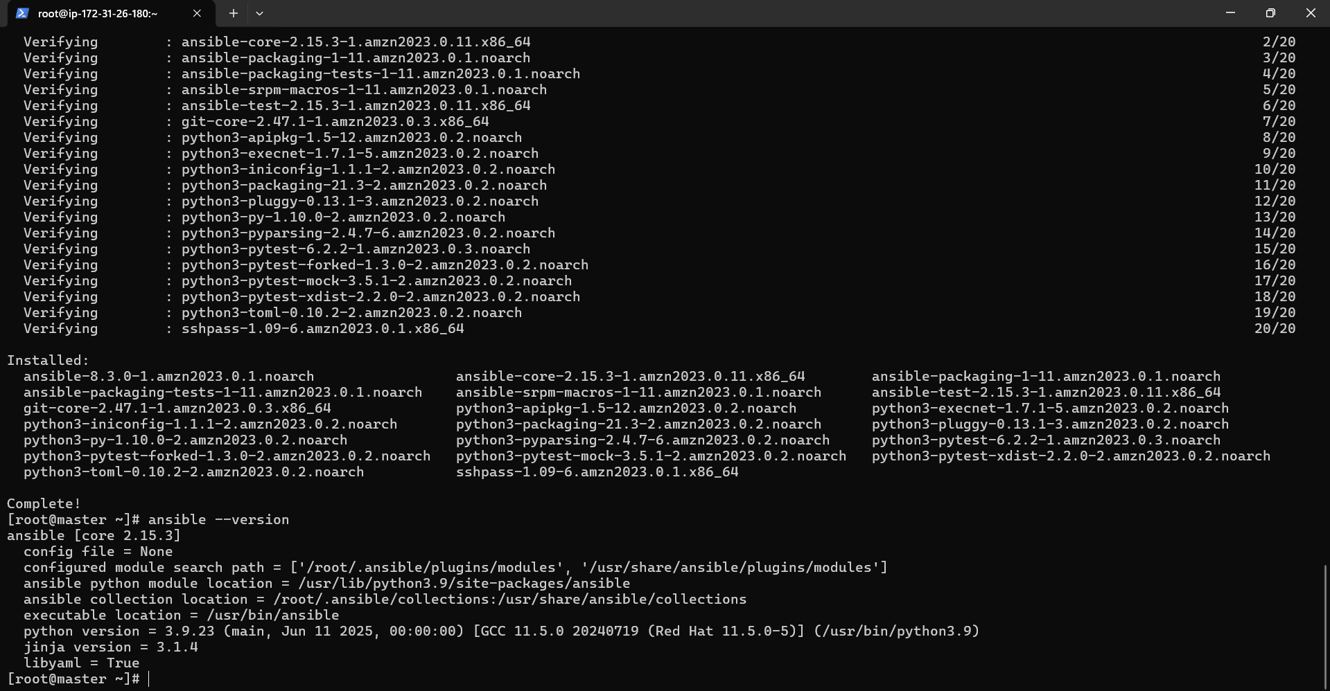

Ansible is available in master node.

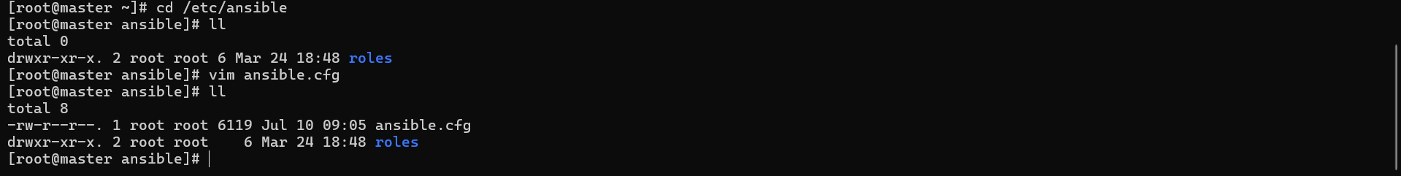

Ansible.cfg file is added.

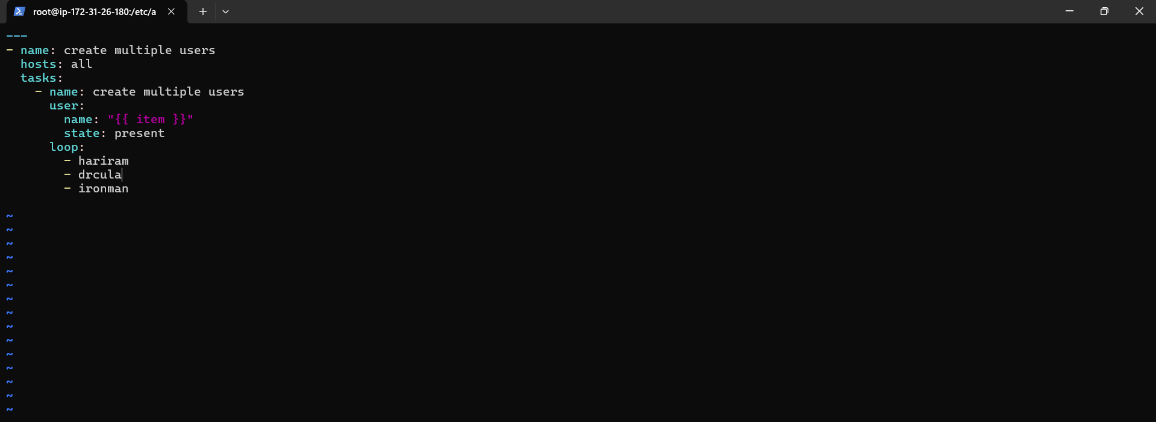

Playbook to add multiple use is added . Users hariram,Dracula,ironman will be added.

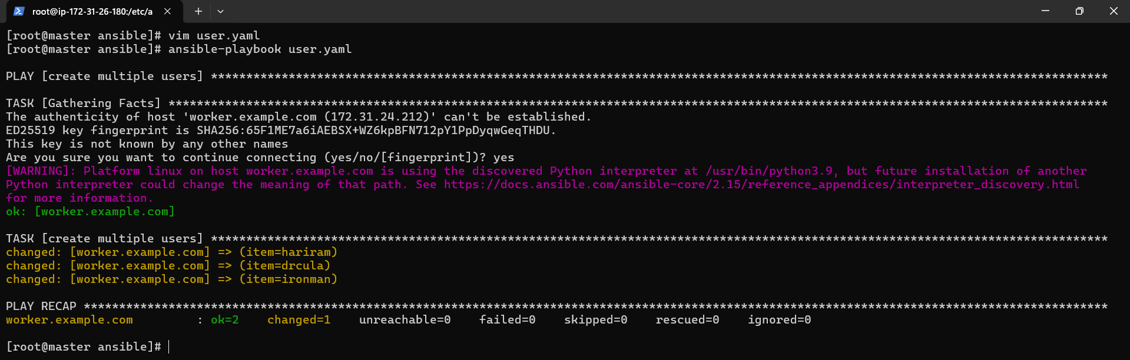

Playbook is applied.



In worker node, using vim/etc/passwd , user added can be confirmed.

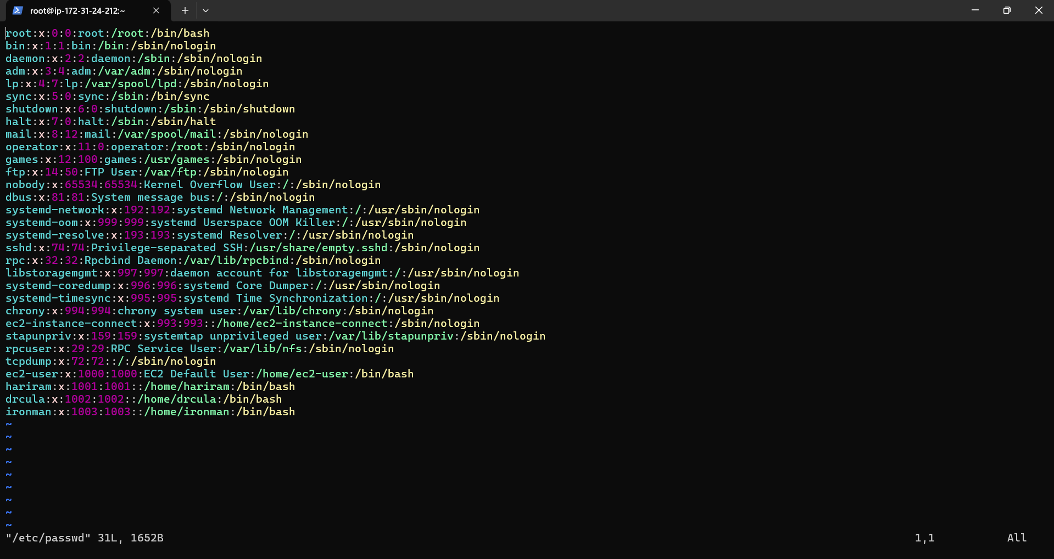

Multiple users added successfully using loop concept.

4)Medium-1

Deploy in a Docker instance and create a Docker image, Store the Docker image in ECR, achieve this image on EkS cluster using the ECR image. Build a sample java web app using maven

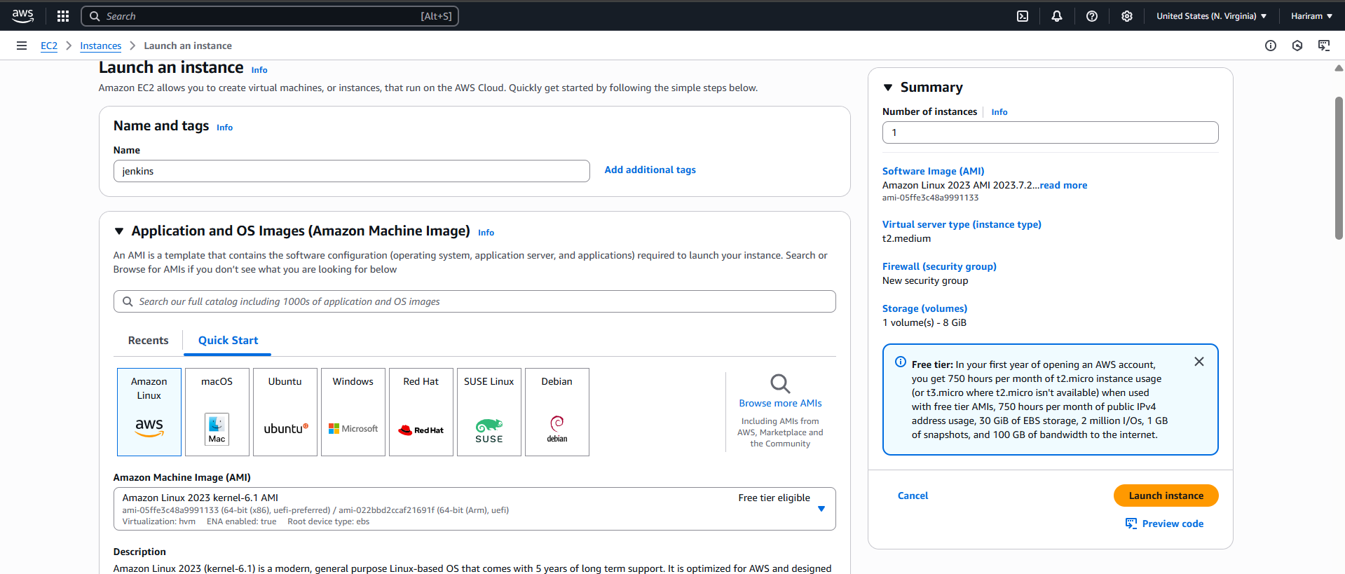

Jenkins instance is created.

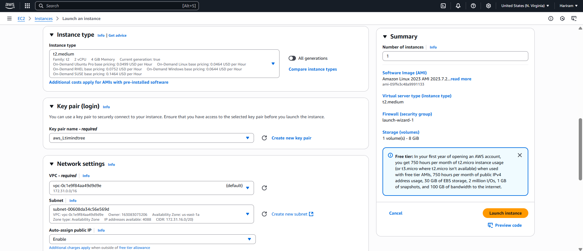

Existing key pair is selected . Existing security group is selected.

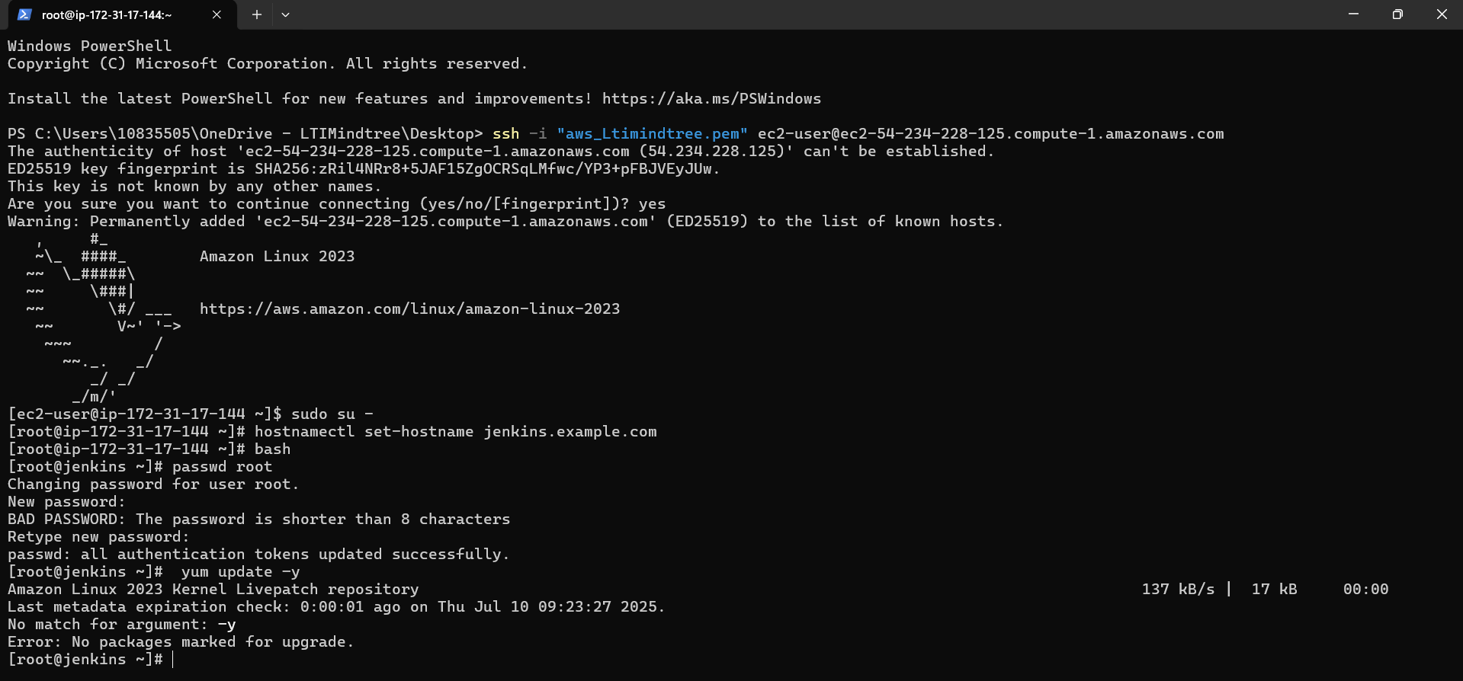

Jenkins is running successfully and necessary dependencies are installing.

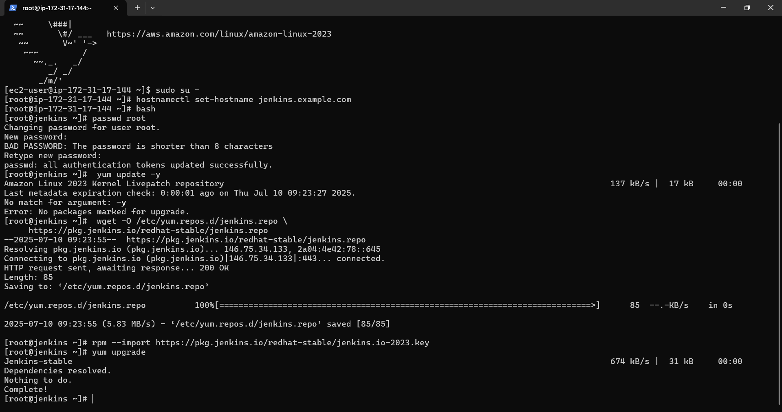

Yum upgrade is done.

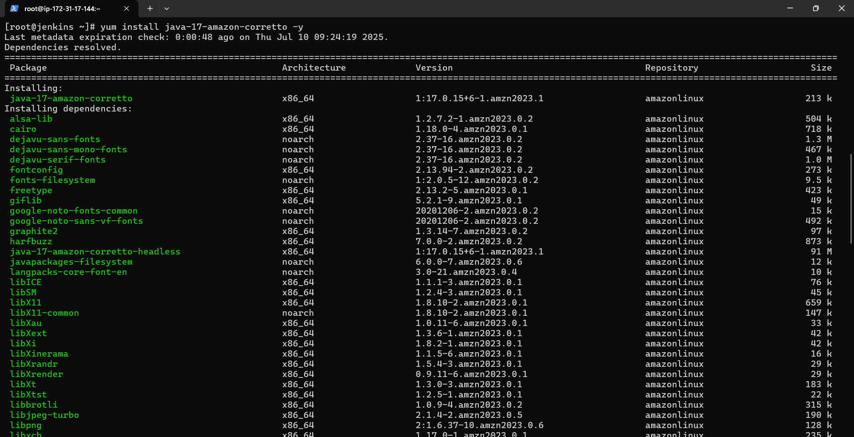

Java is installed.

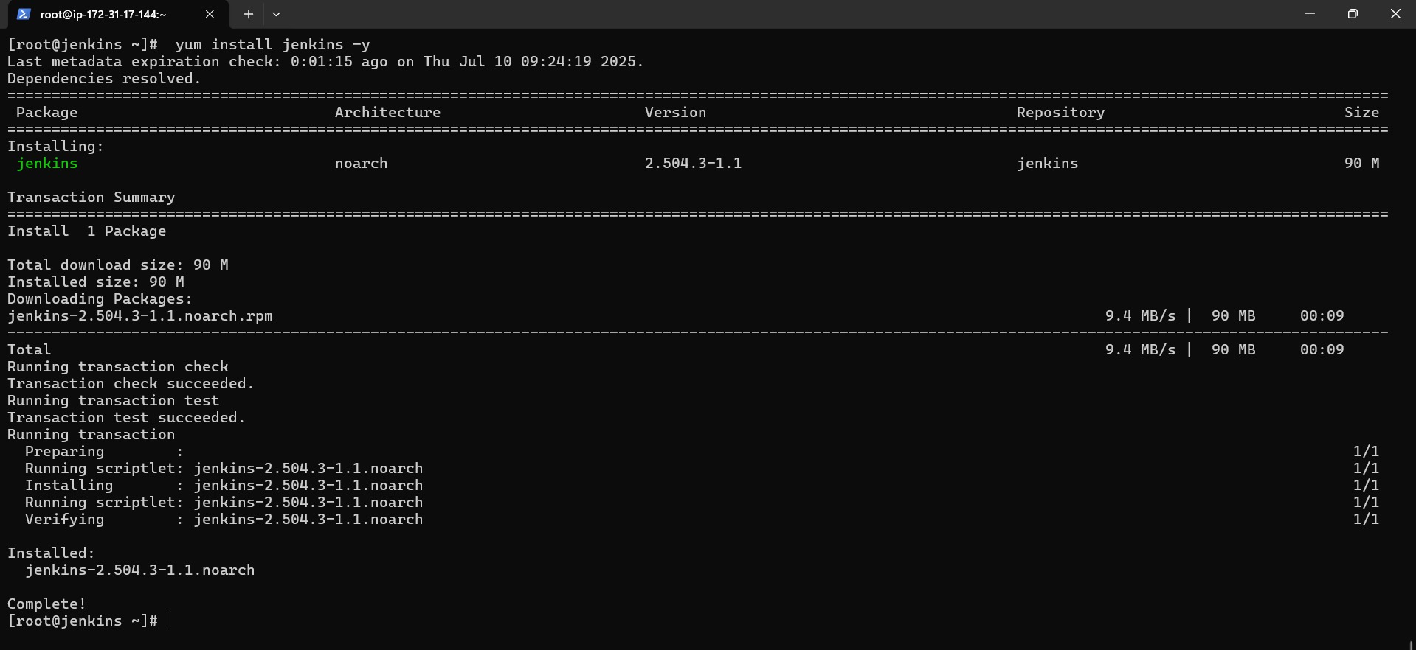

Jenkins is installed.

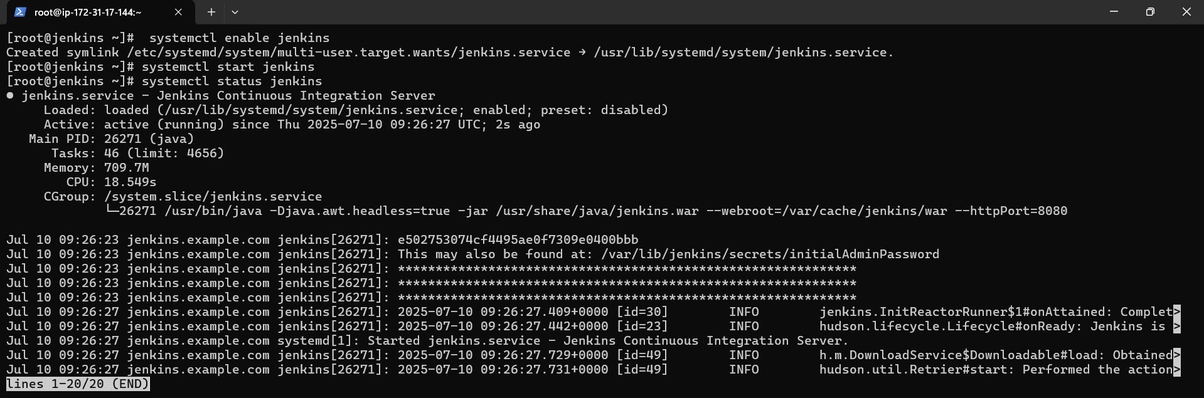

Jenkins is started and enabled. Jenkins status is active.

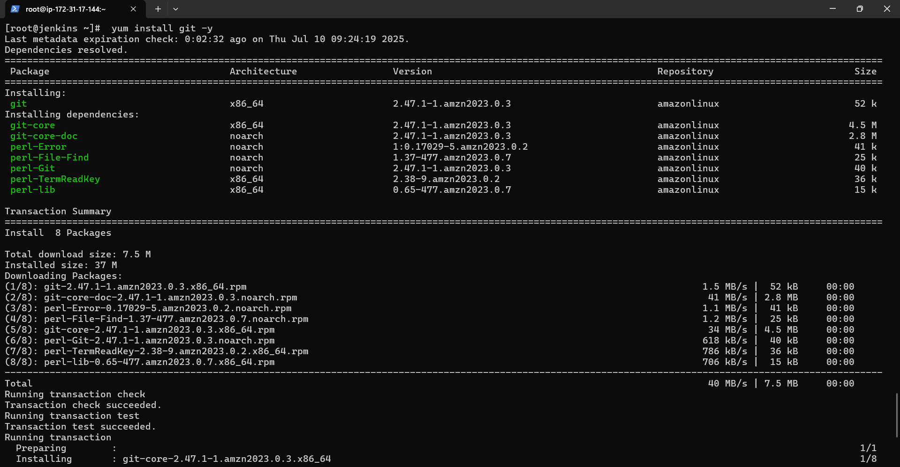

Git is installed.

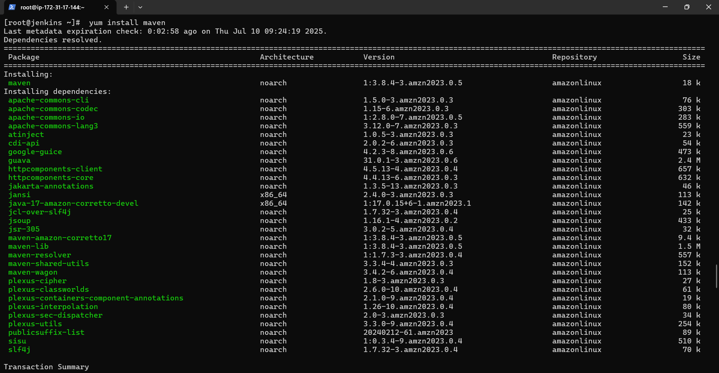

Maven is installed.

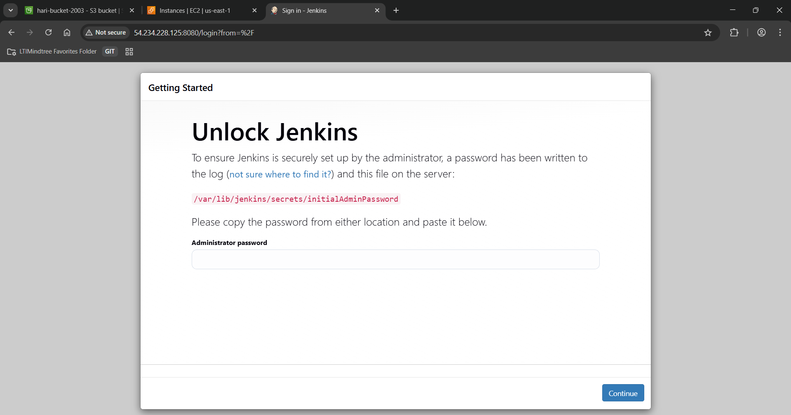

Jenkins dashboard is accessed using instances public ip:8080.

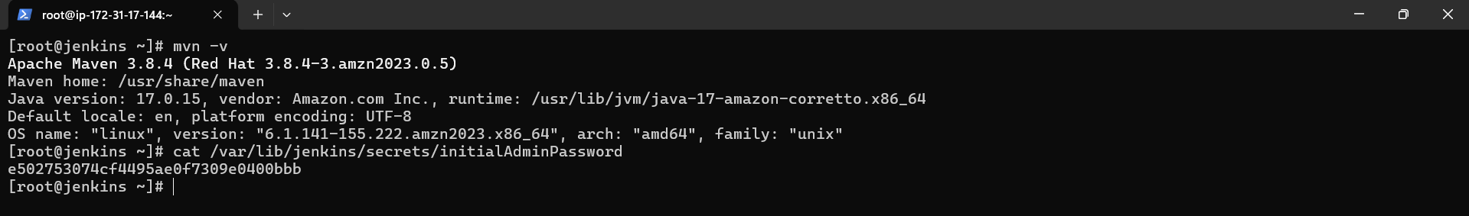

Password is taken from Jenkins terminal.

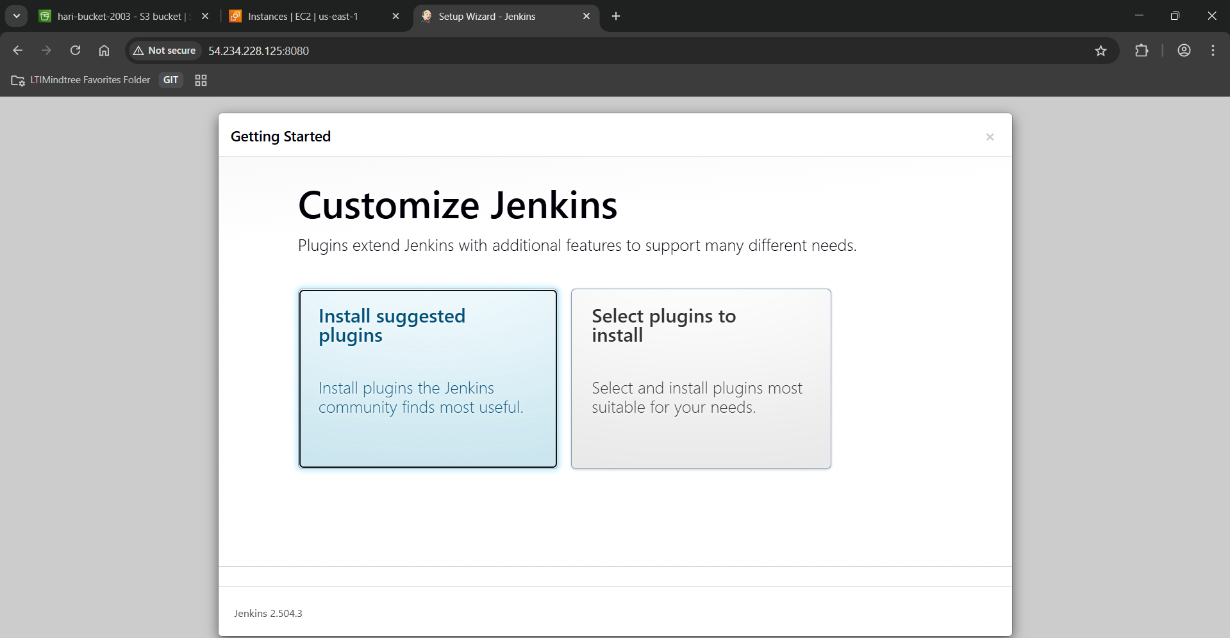

Suggested plugins are installing.

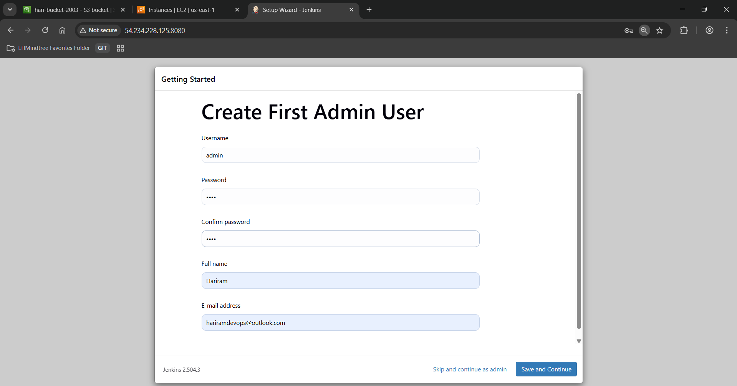

Admin user is created.

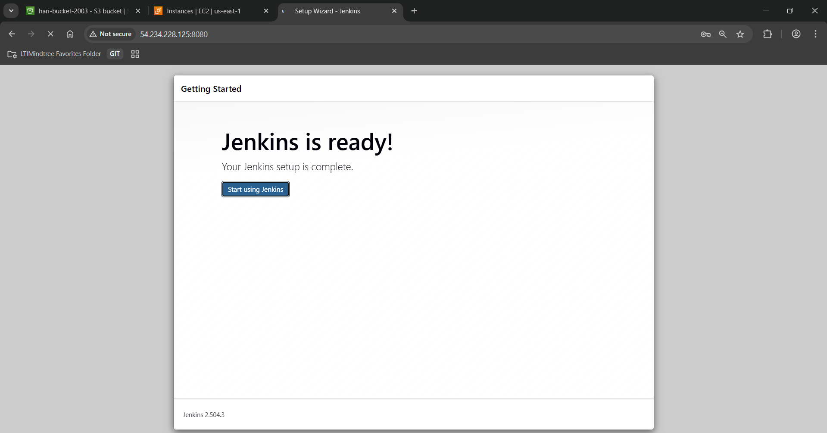

Jenkins is ready to used.

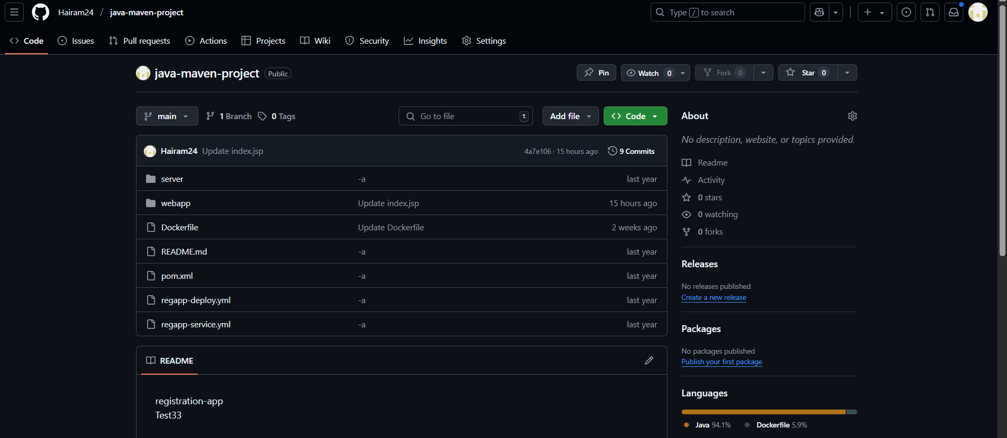

Existing repository is use where maven project is available.

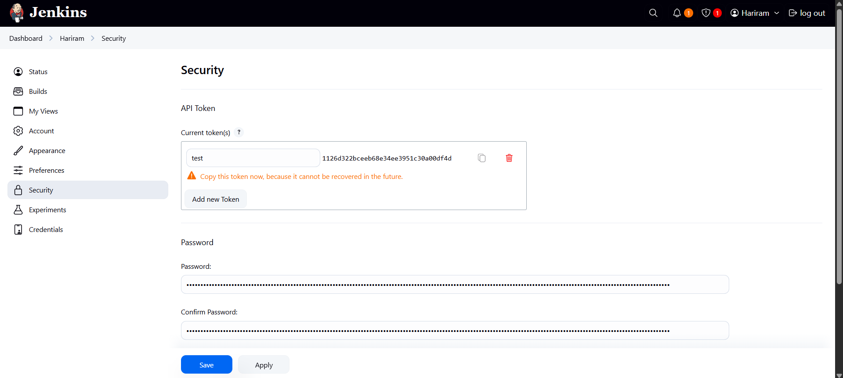

Token is generate in Jenkins to connect it with github.

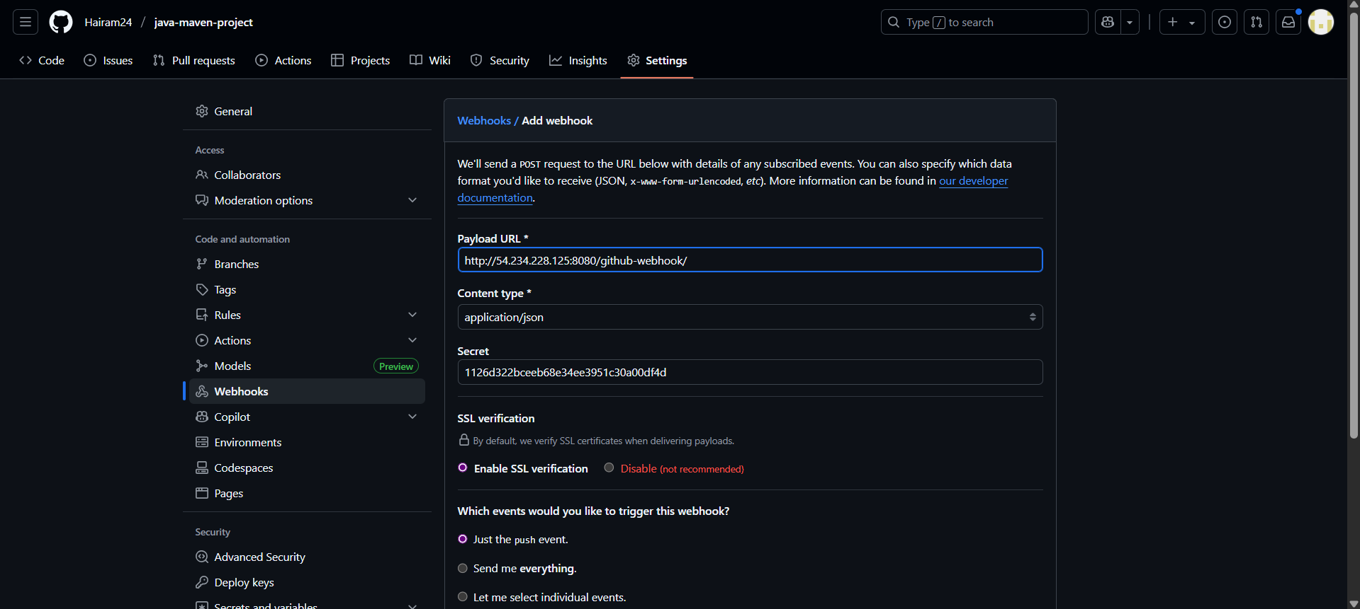

Token is pasted in git webhook and Jenkins url is pasted.

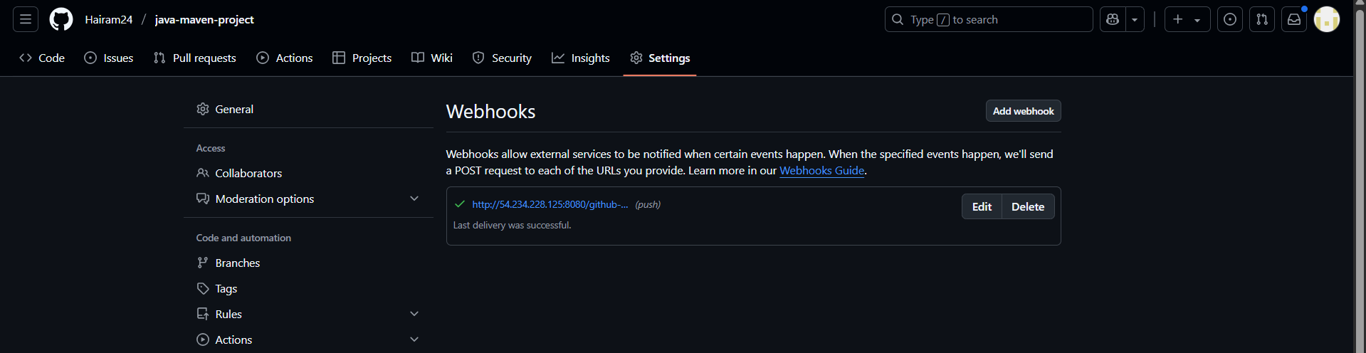

Webhooks is added successfully.

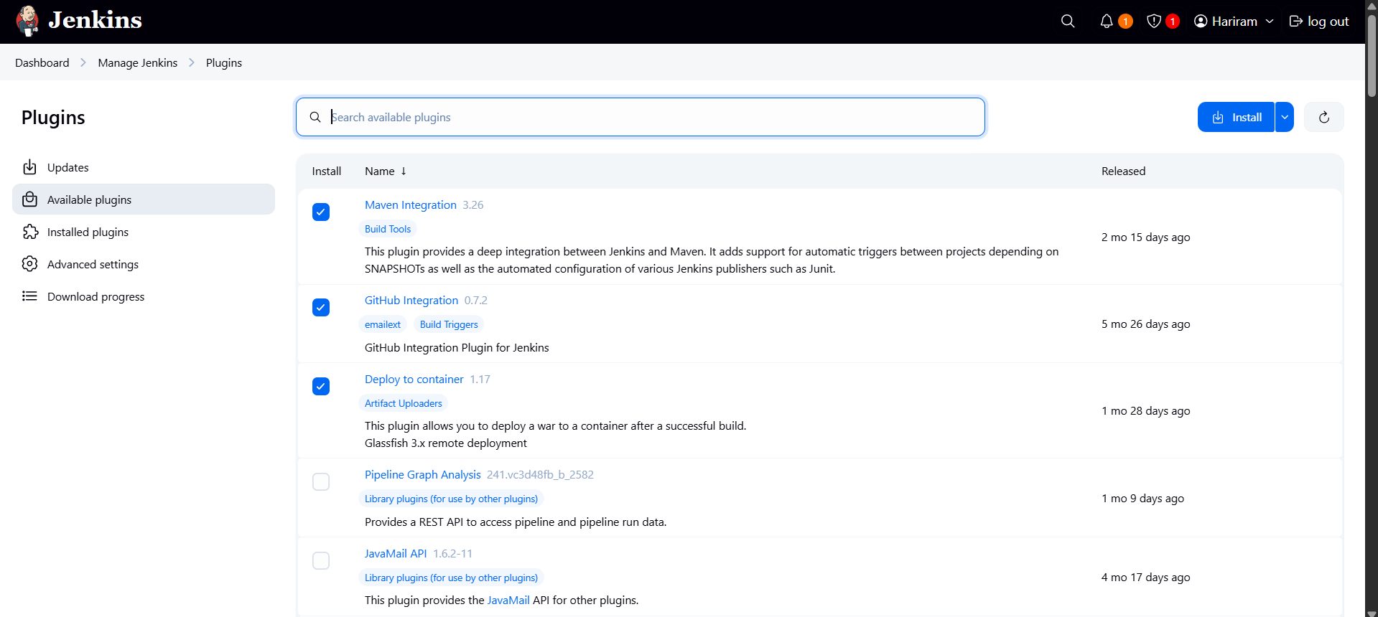

Necessary plugins are added.

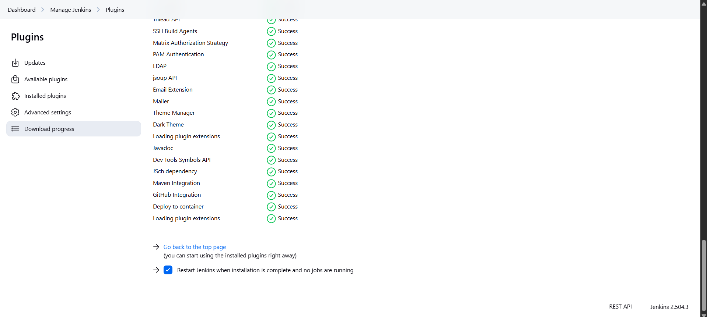

Restarted after installation.

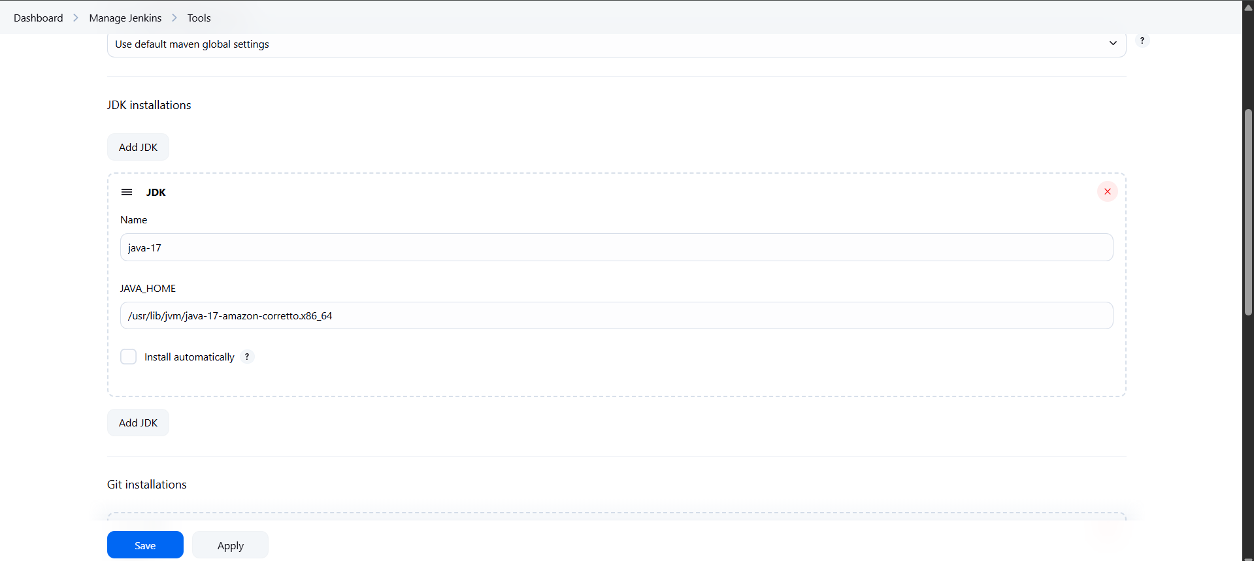

Java path is added from the Jenkins terminal.

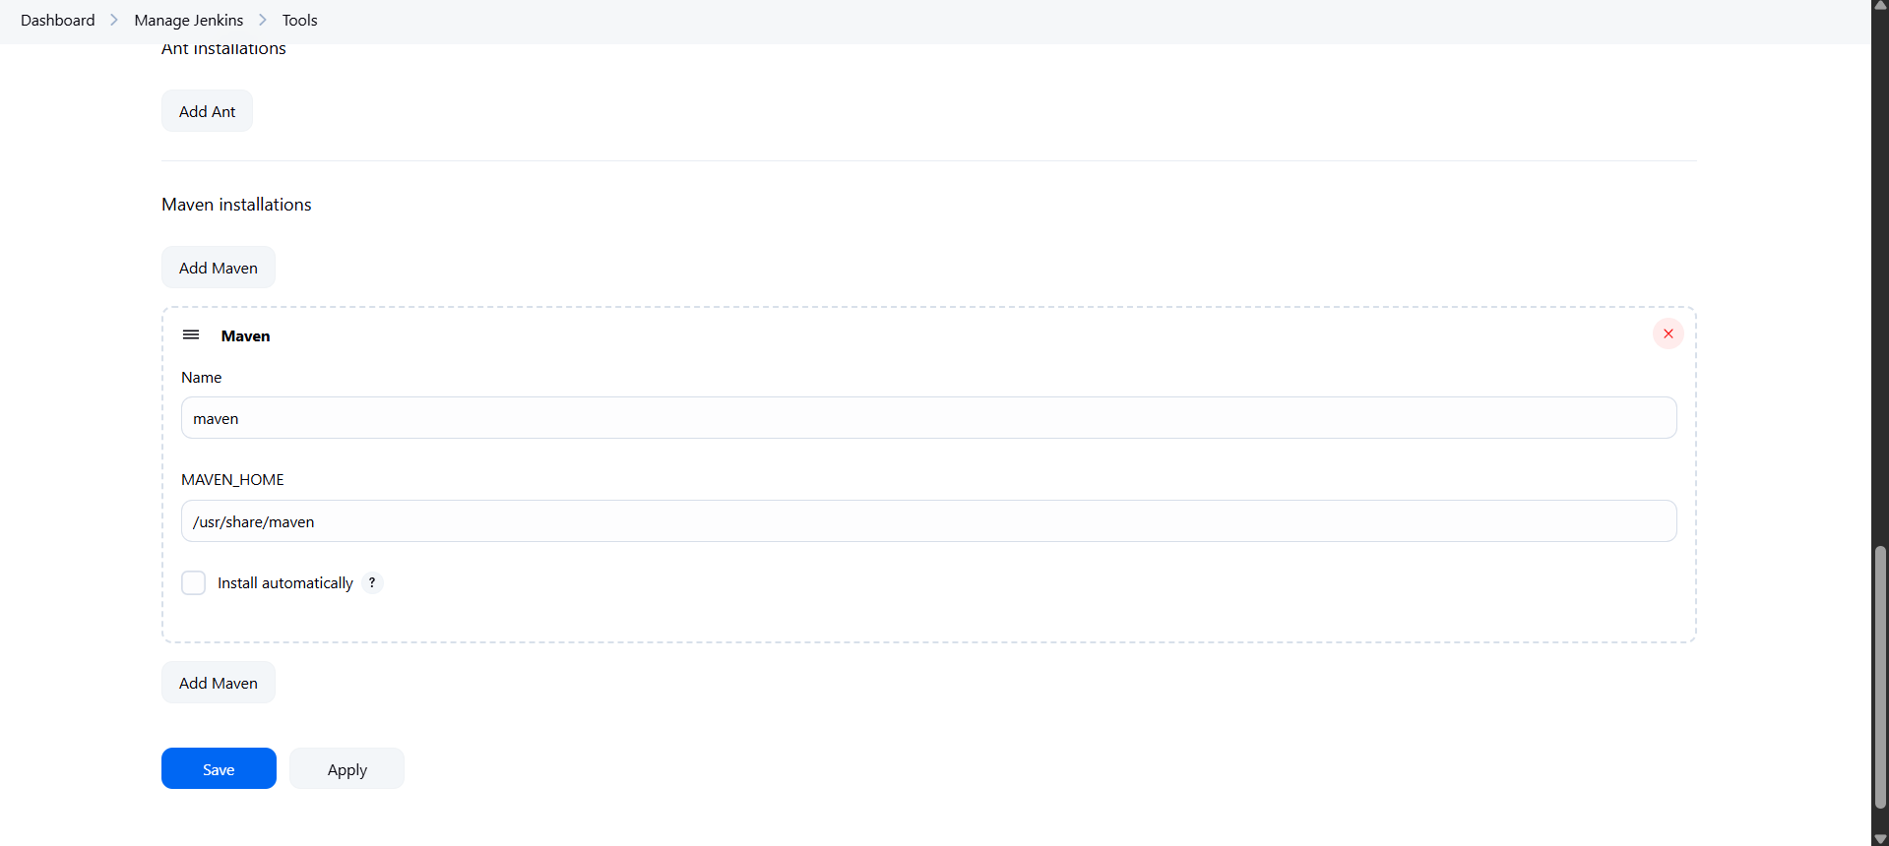

Maven path is added from the Jenkins terminal.

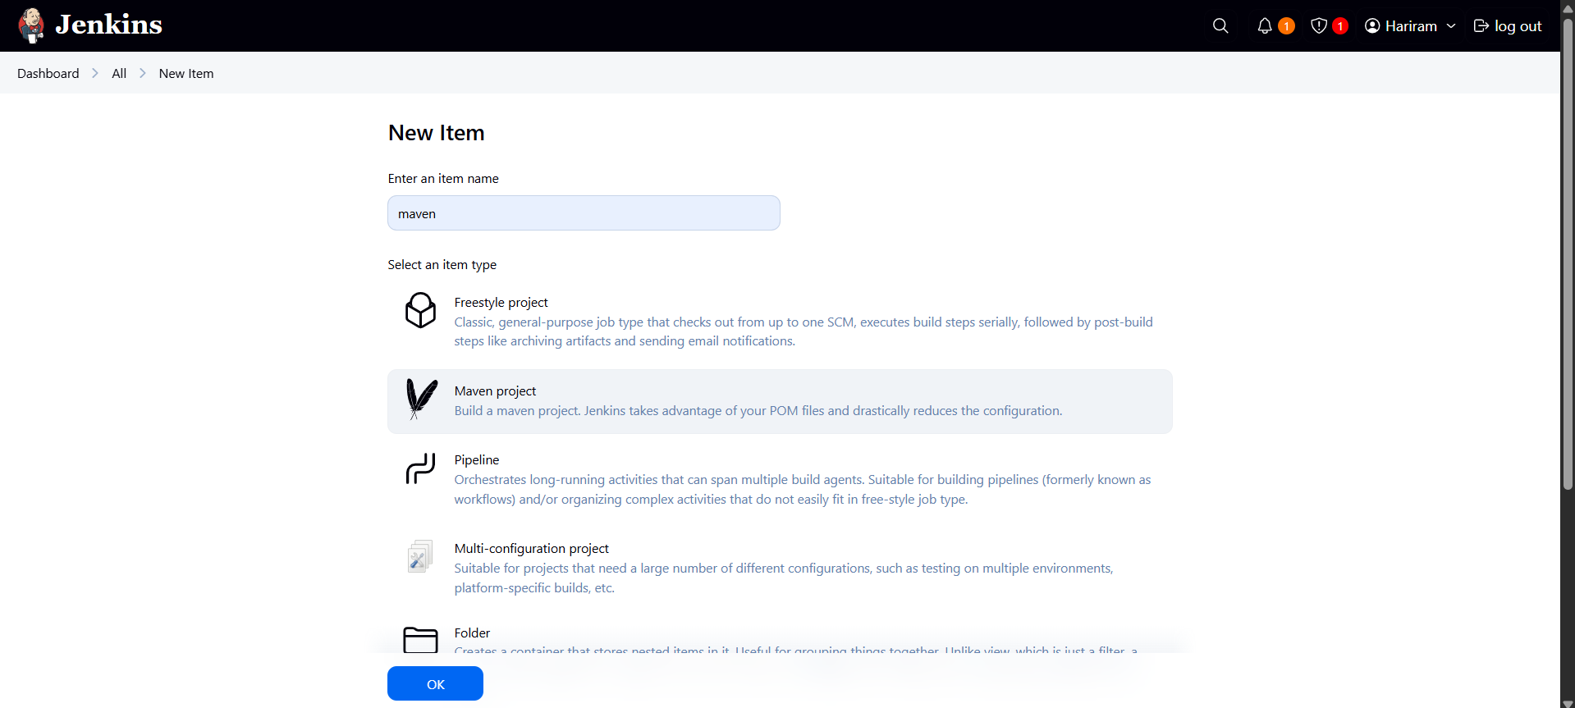

New maven project is created.

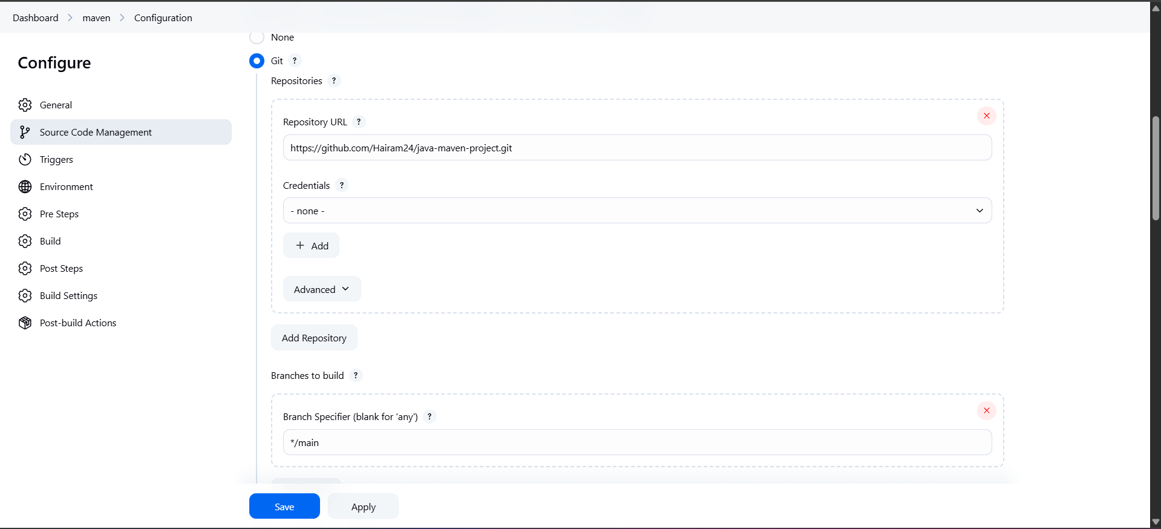

Git http link is added and /master is changed to /main.

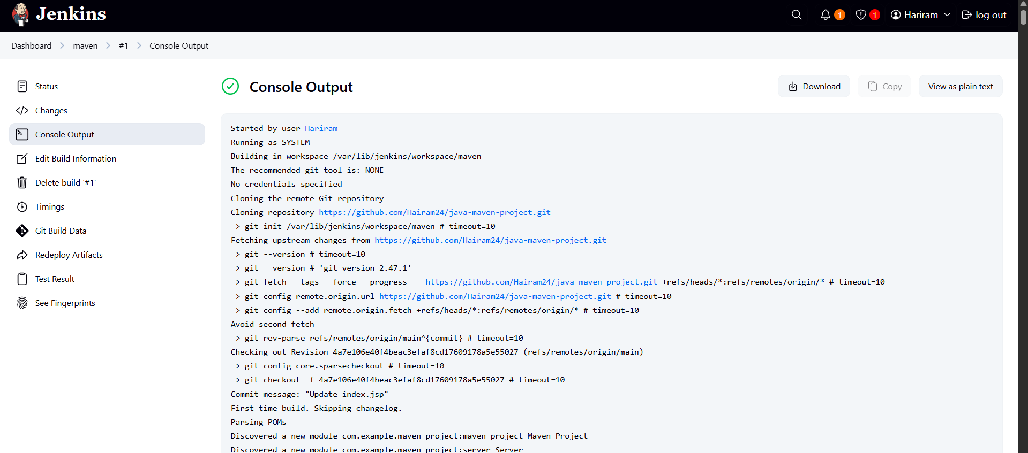

Build is successful and war is created in the Jenkins.

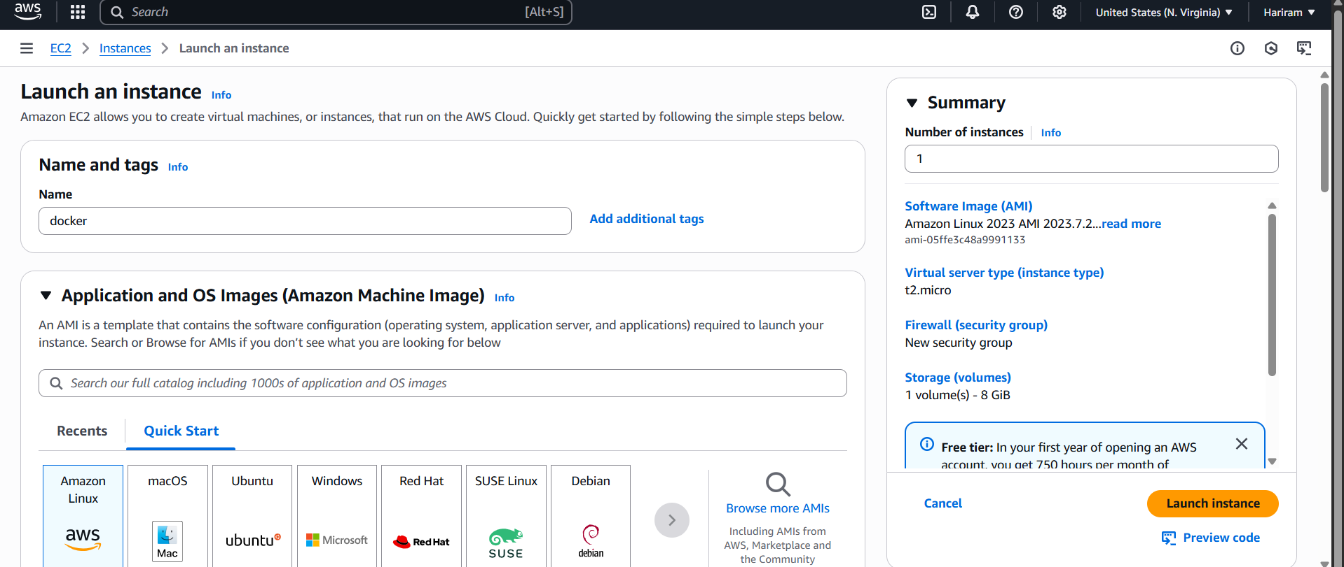

Docker instance is created.

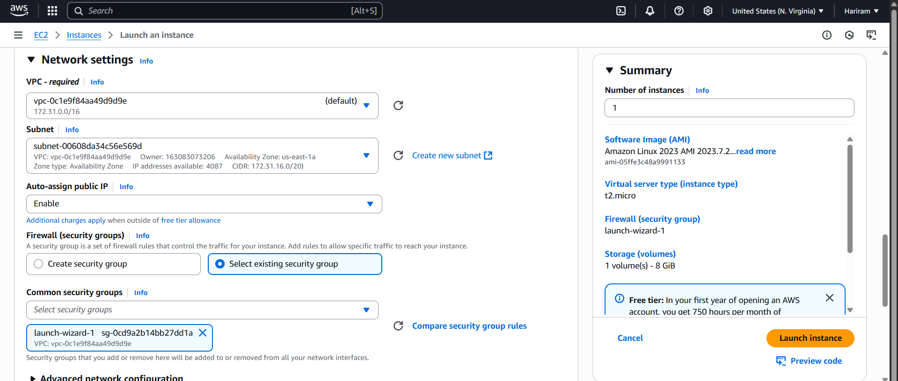

Existing key pair is selected and existing security group is selected.

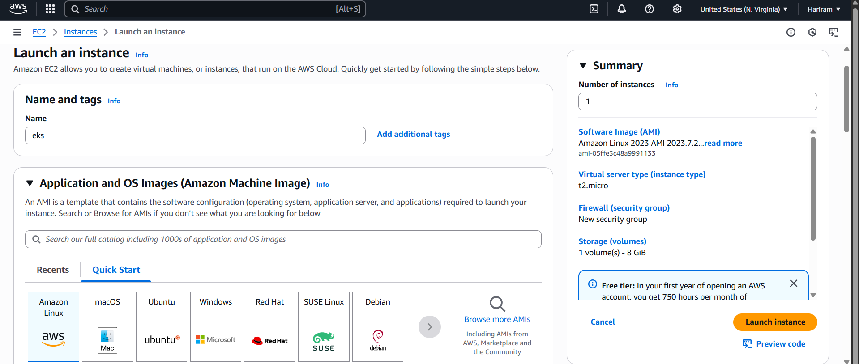

Eks instance is created.

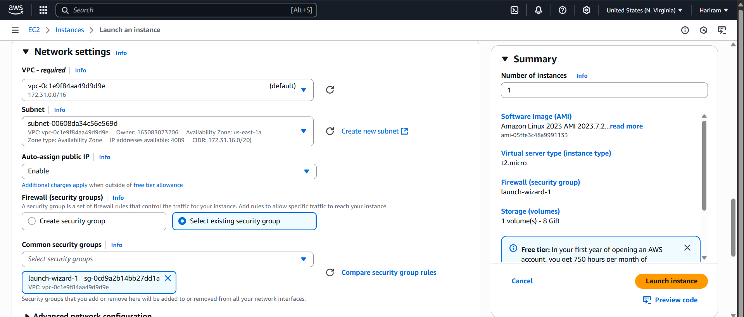

Existing key pair is selected and existing security group is selected.

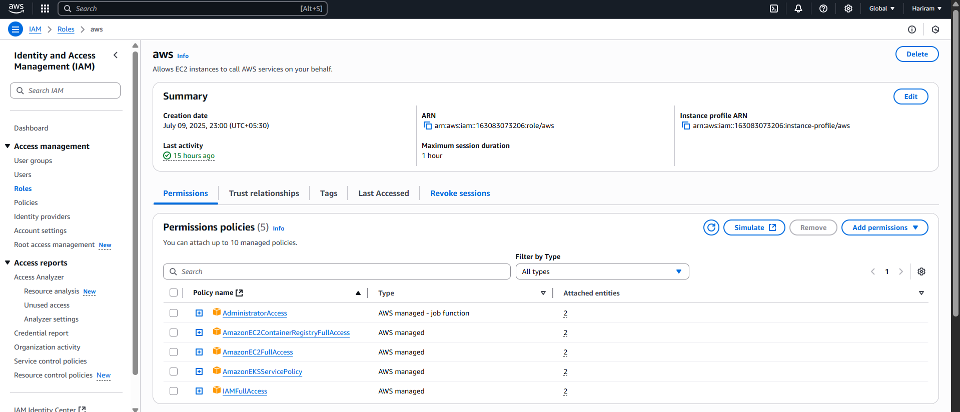

Role is created with necessary permissions.

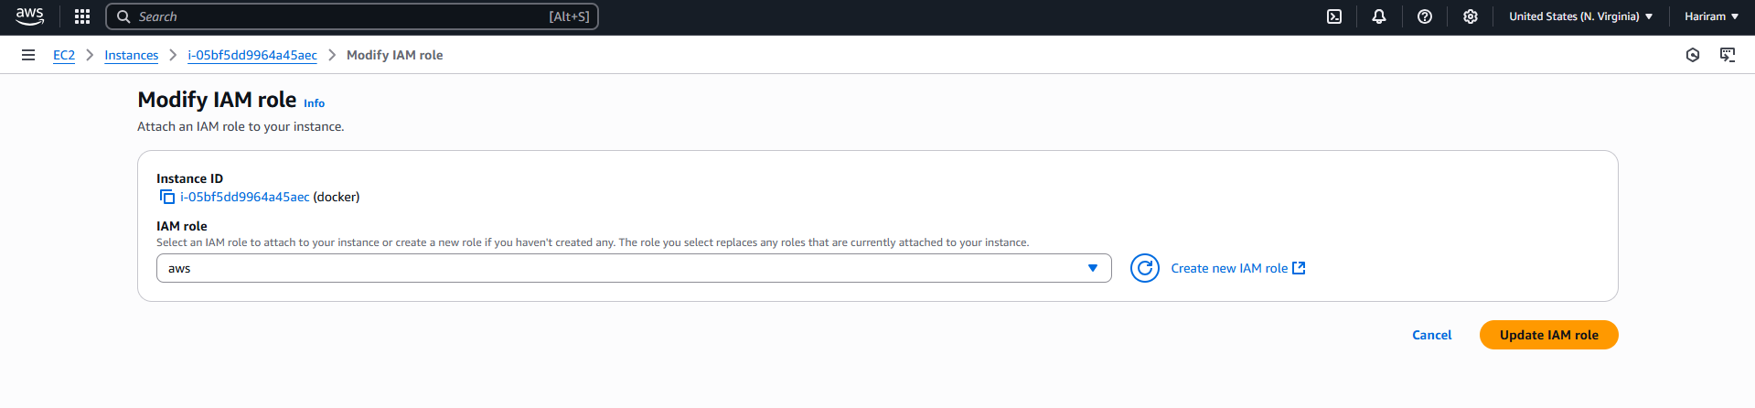

Role Added to docker instance.

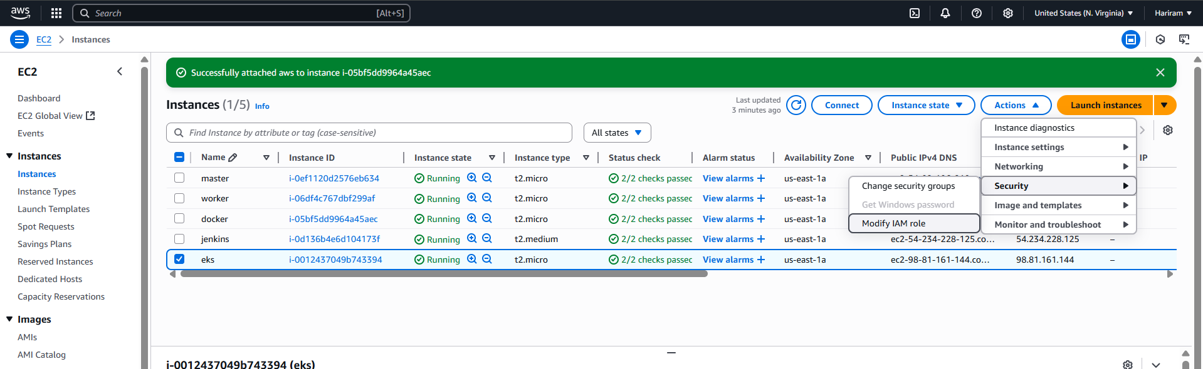

Role added to eks instance.

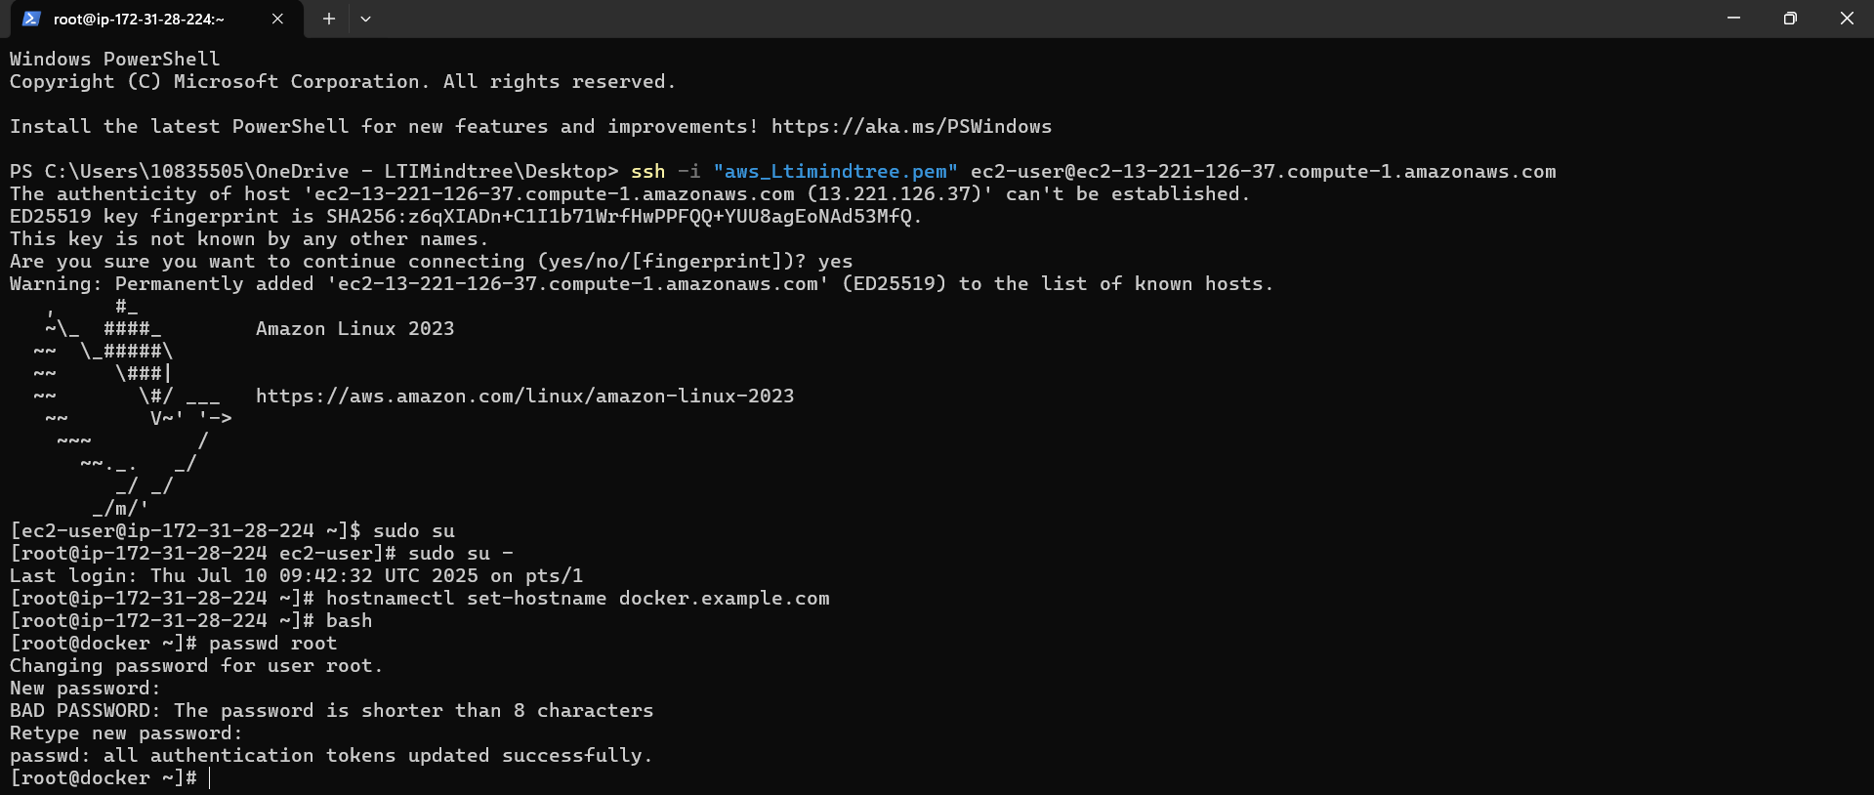

Docker instance is accessible,

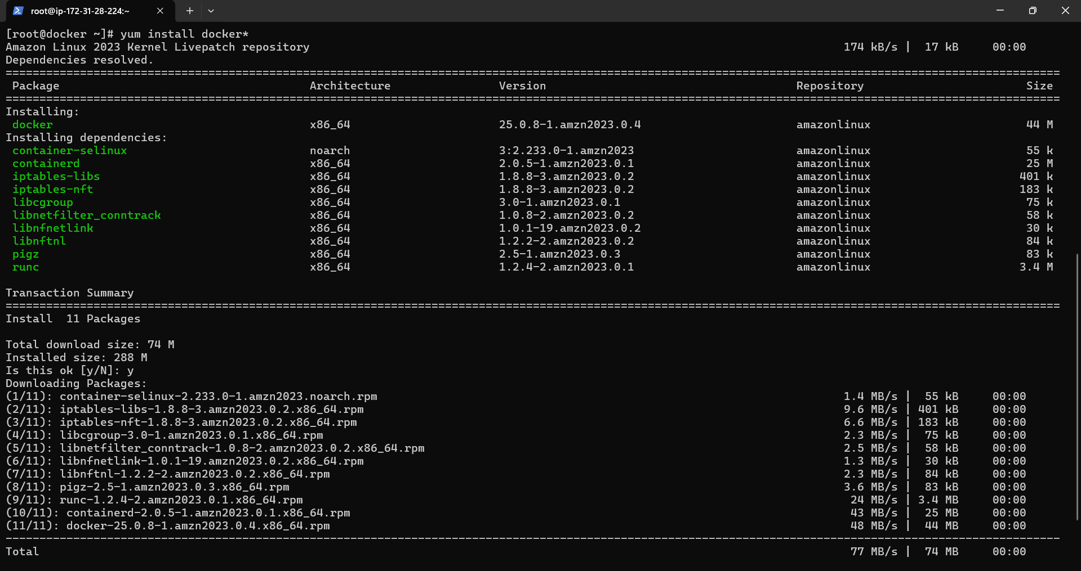

Docker is installed.

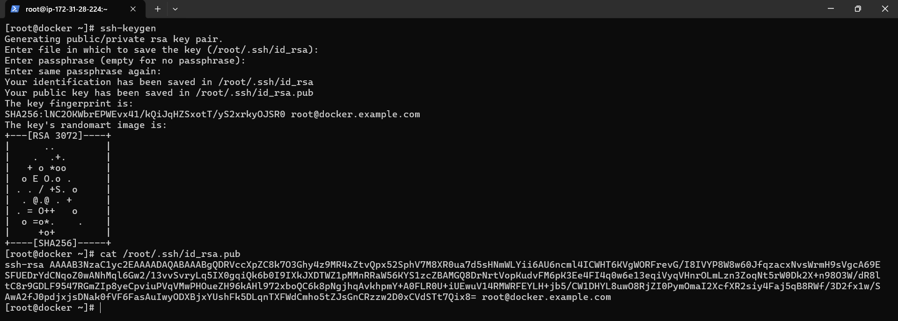

Ssh-keygen is done in docker.

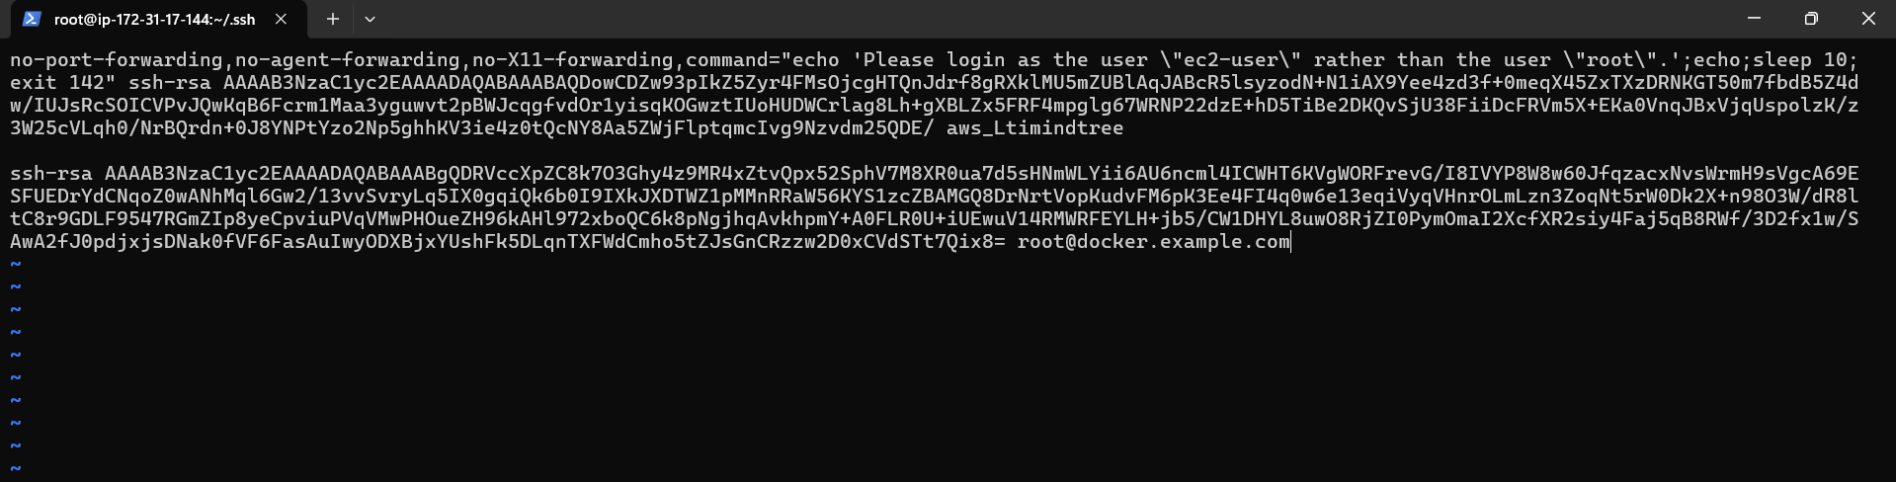

Docker pub key is added to the Jenkins.

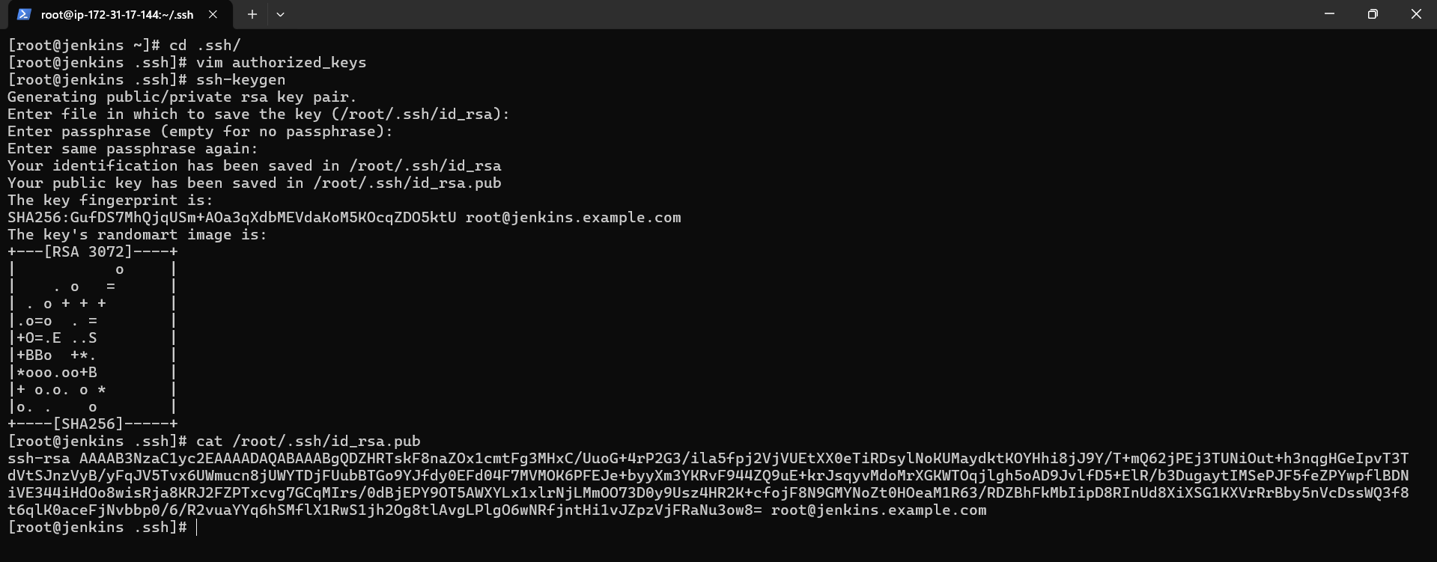

ssh-keygen is done in Jenkins.

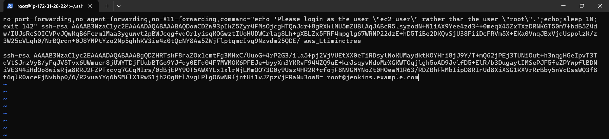

Jenkins pub key is added to the docker.

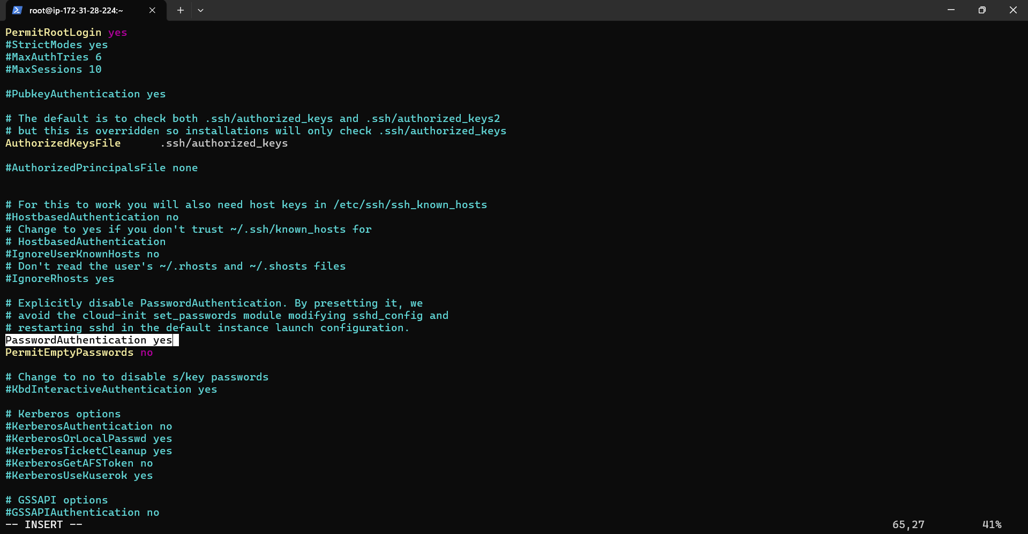

Sshd config is done in docker with password auth and permit login enabled.



Sshd is restarted and enabled.

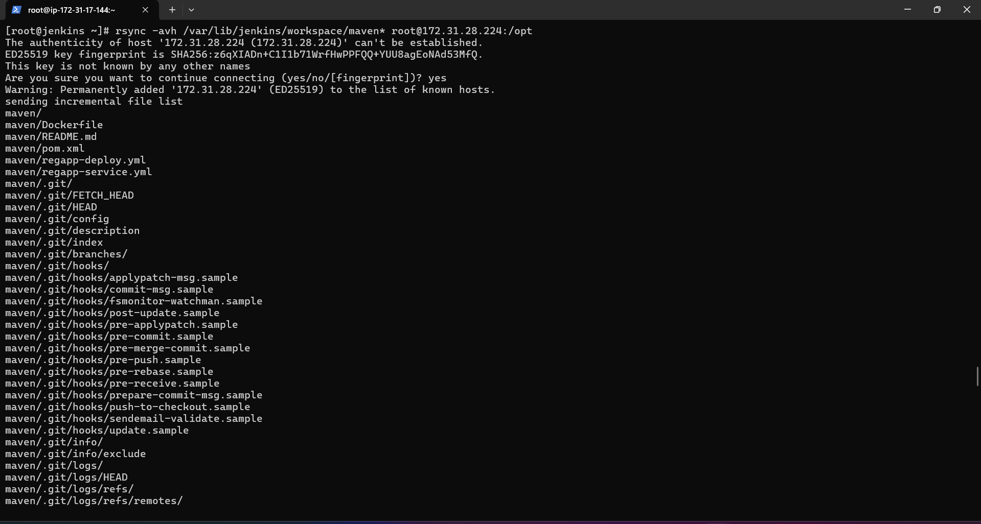

Using rsync cmd build maven project with war file is copied from Jenkins to the docker /opt folder.

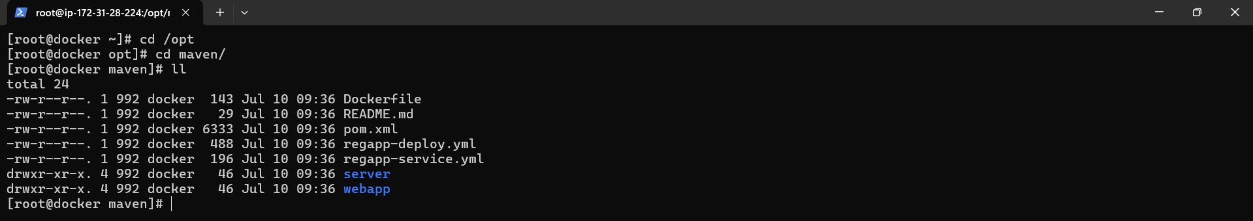

Files successfully copied to /opt of docker.

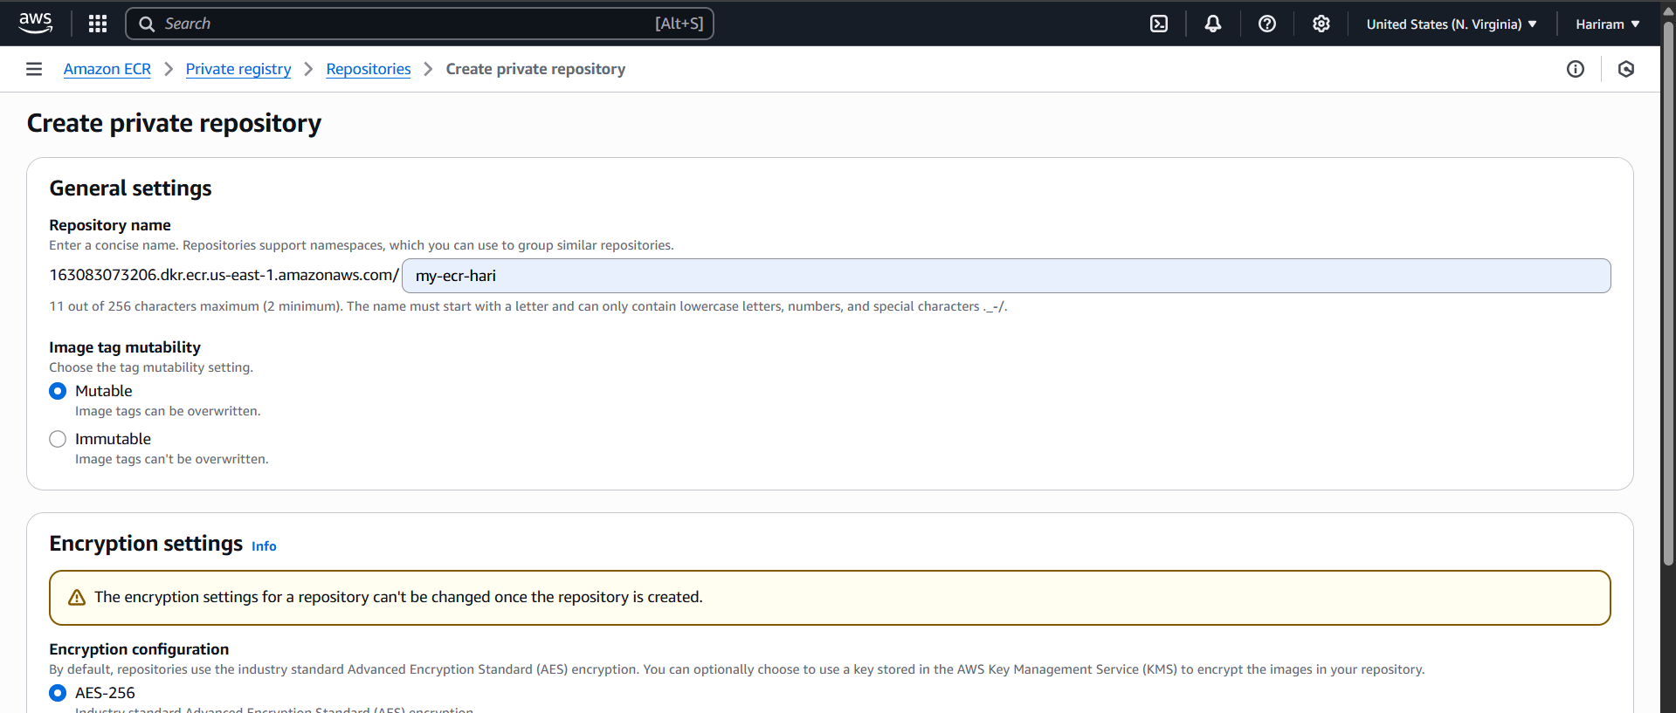

ECR is created.

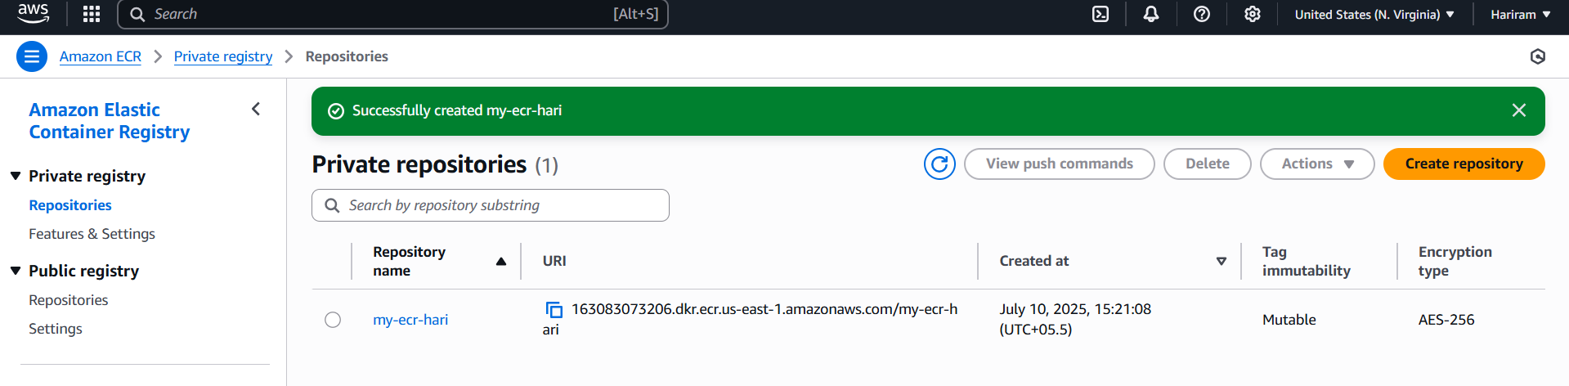

Ecr created successfully.

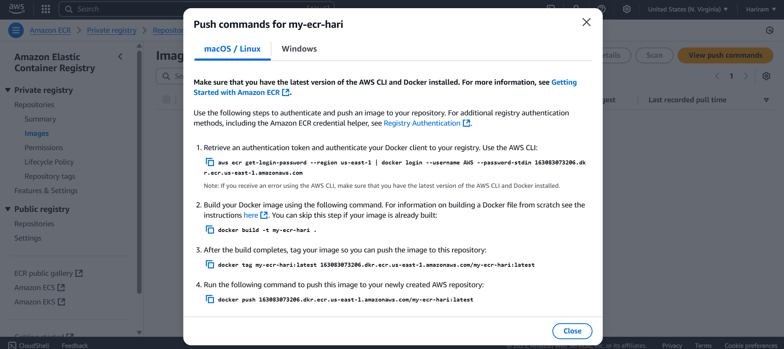

Push commands are taken from ecr.

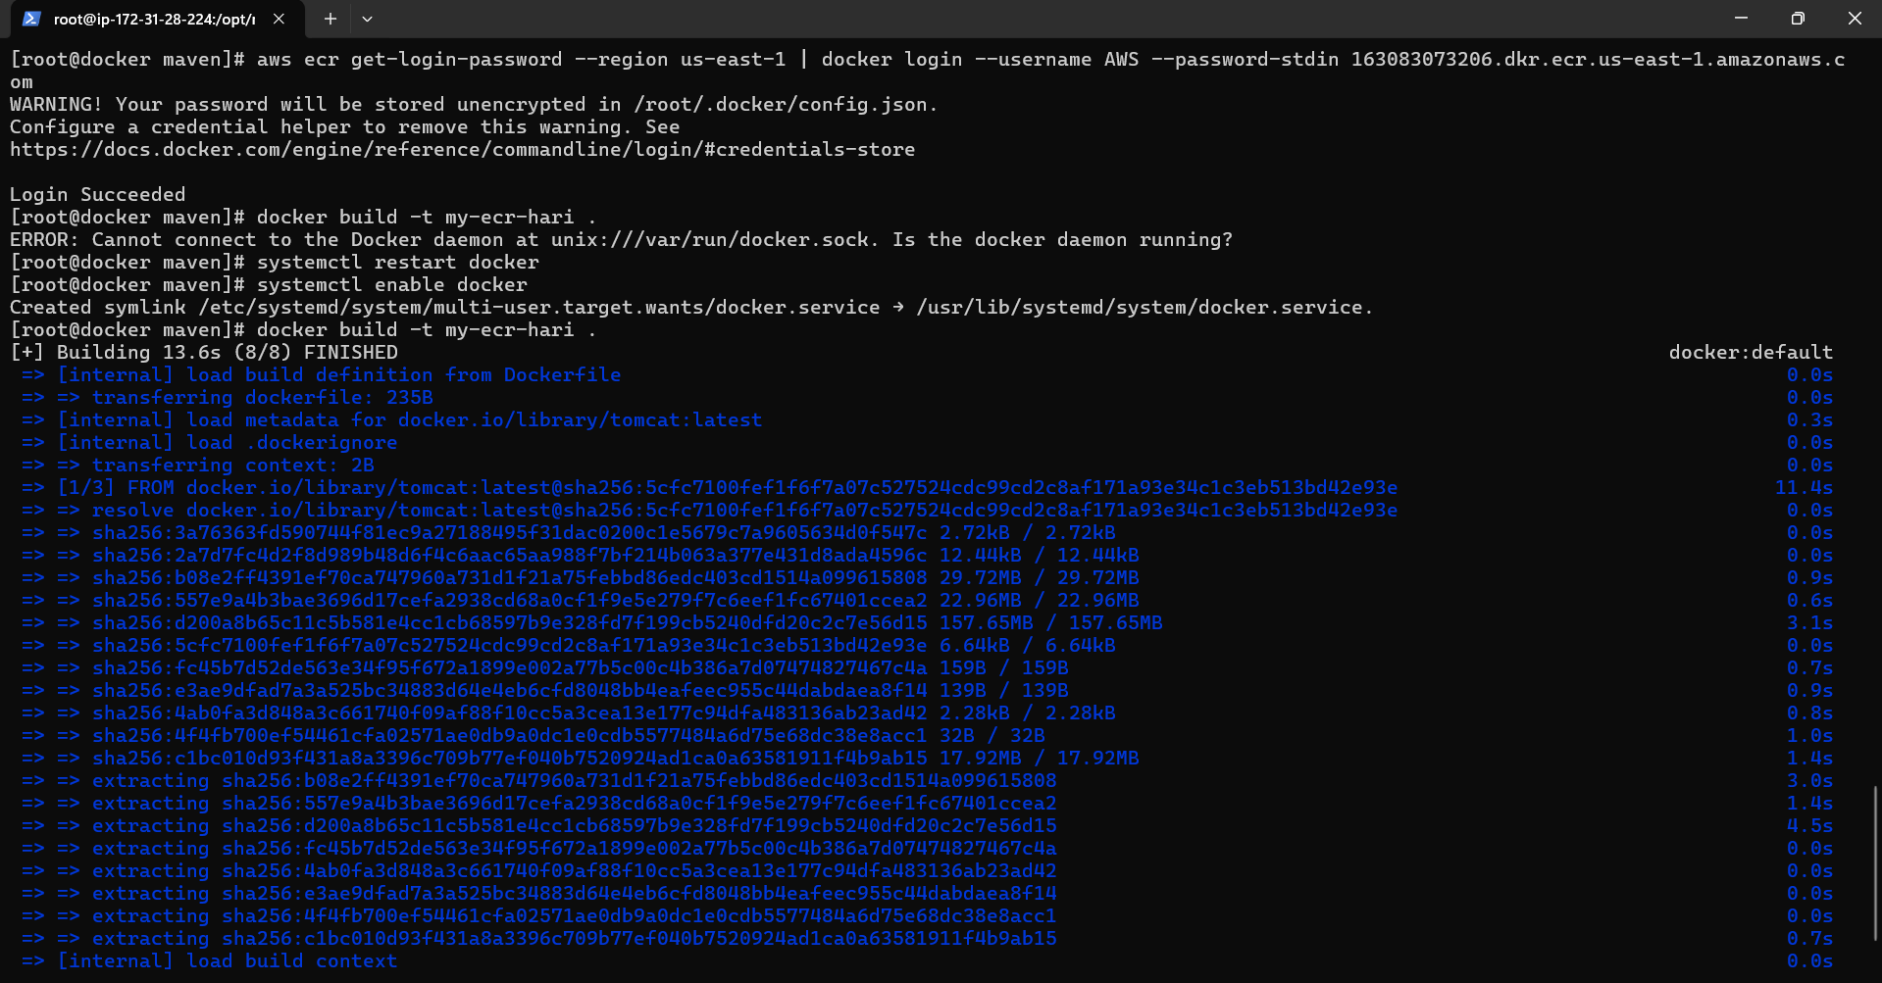

Push cmd is pasted and successfully logged in.

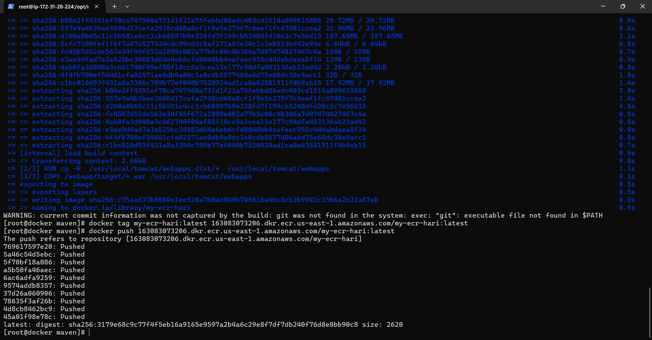

Image is created and pushed into the ECR.

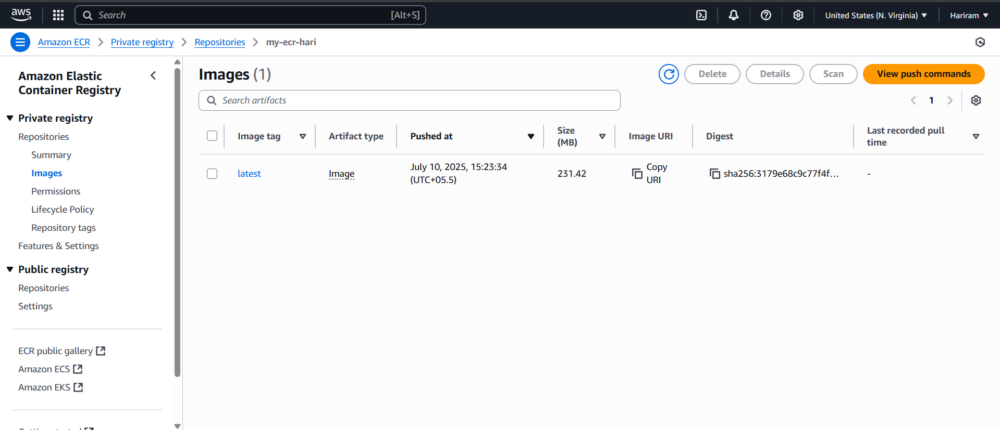

Latest image is available.

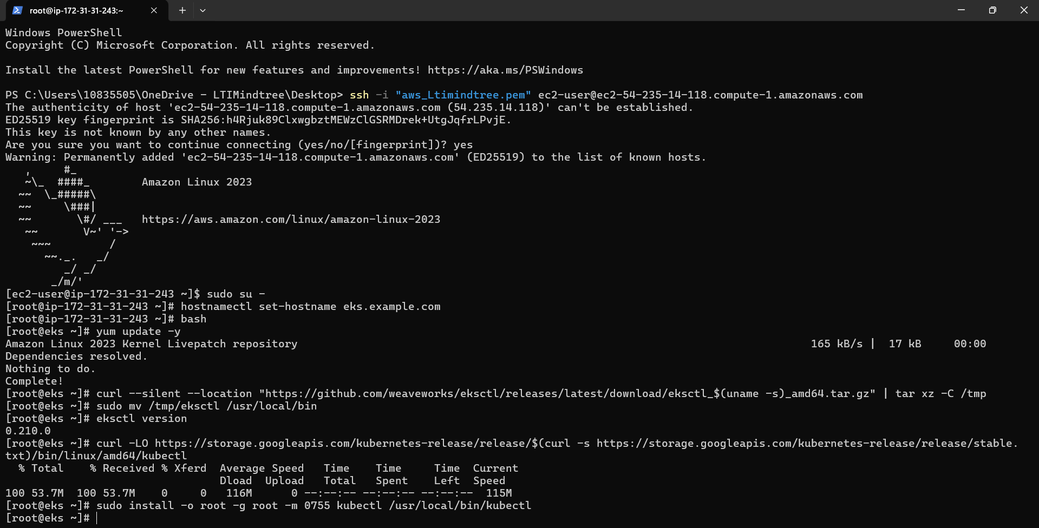

Eks instance is accessible. Necessary dependencies are installed.

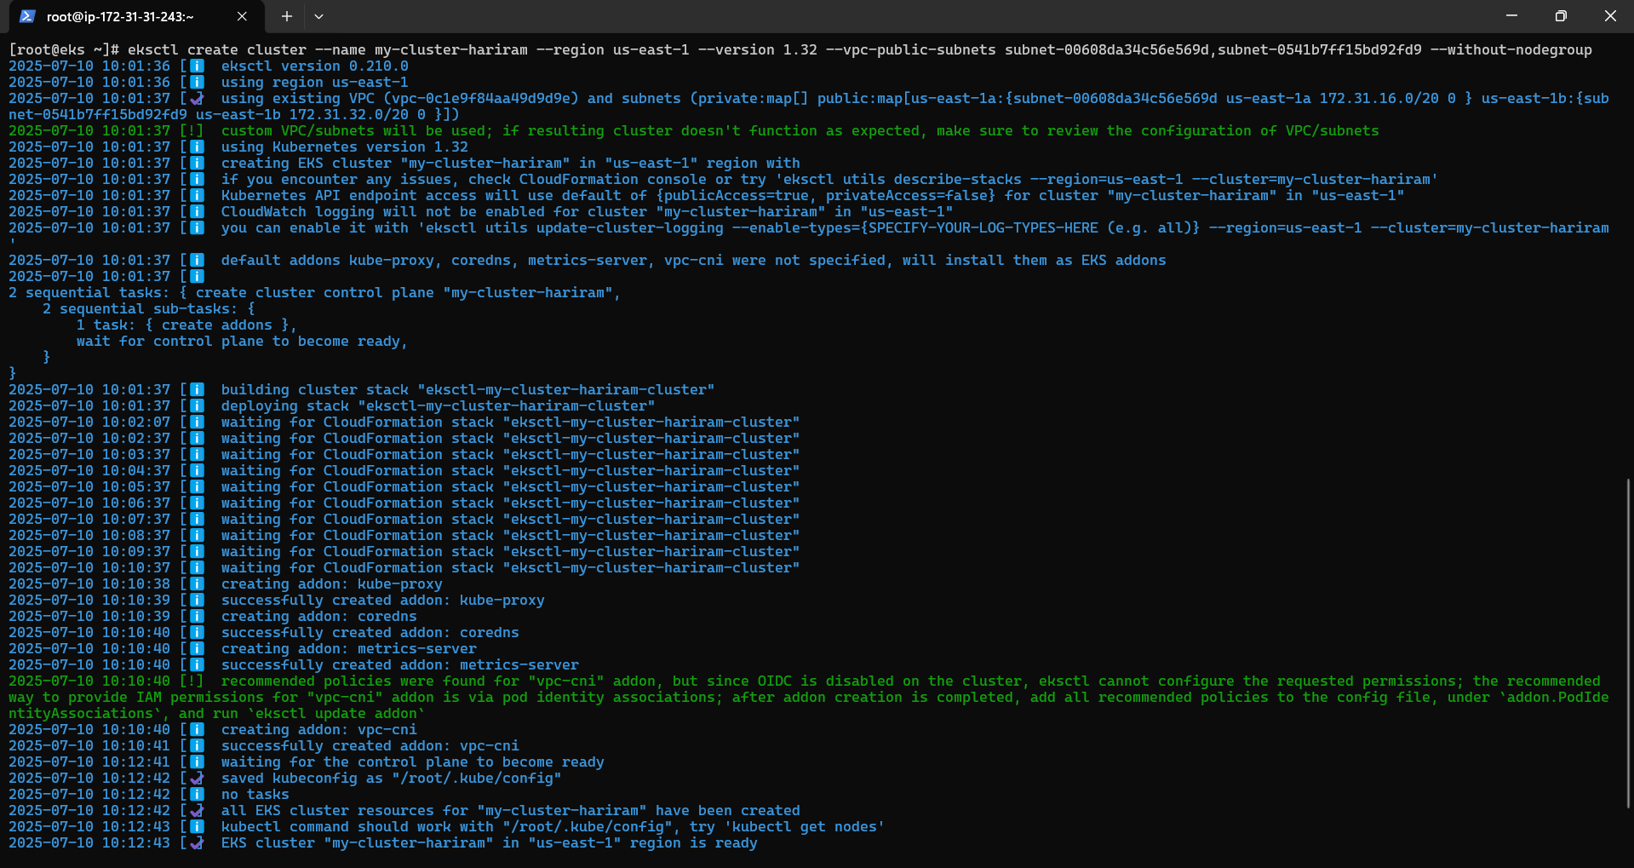

Cluster is created.

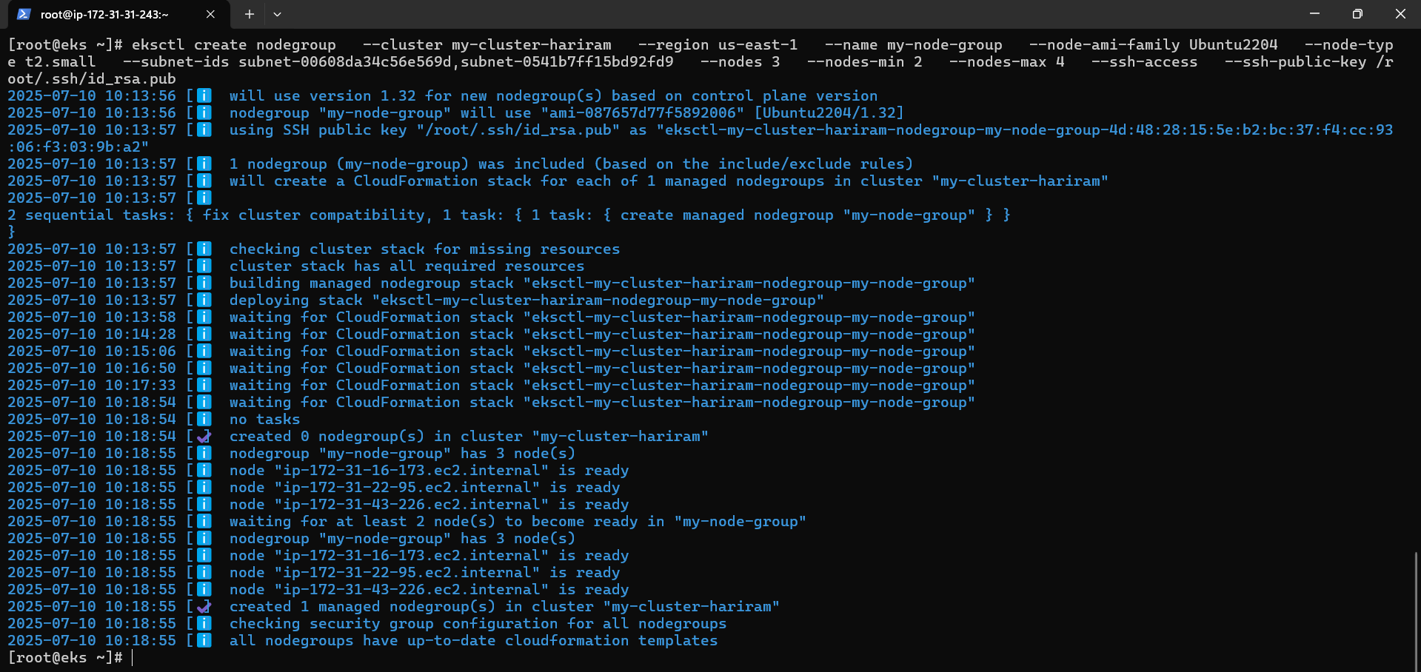

Node group is created.

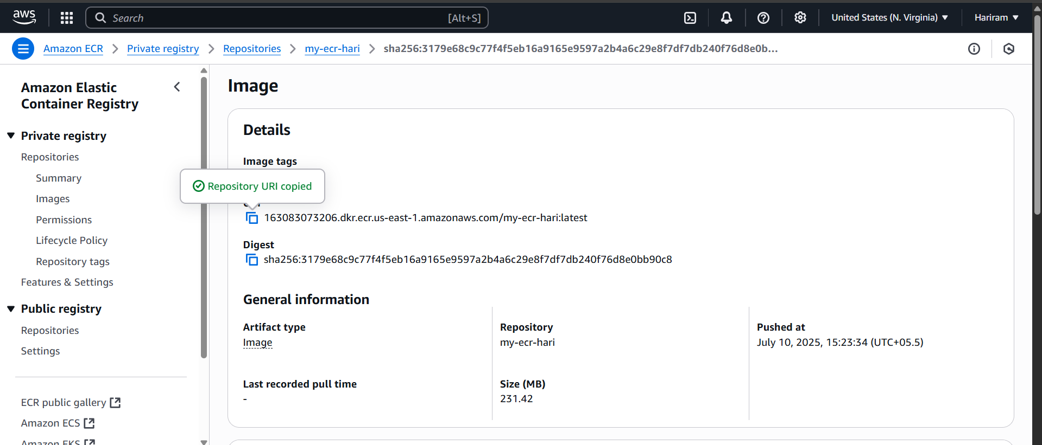

URI of the latest image is copied.

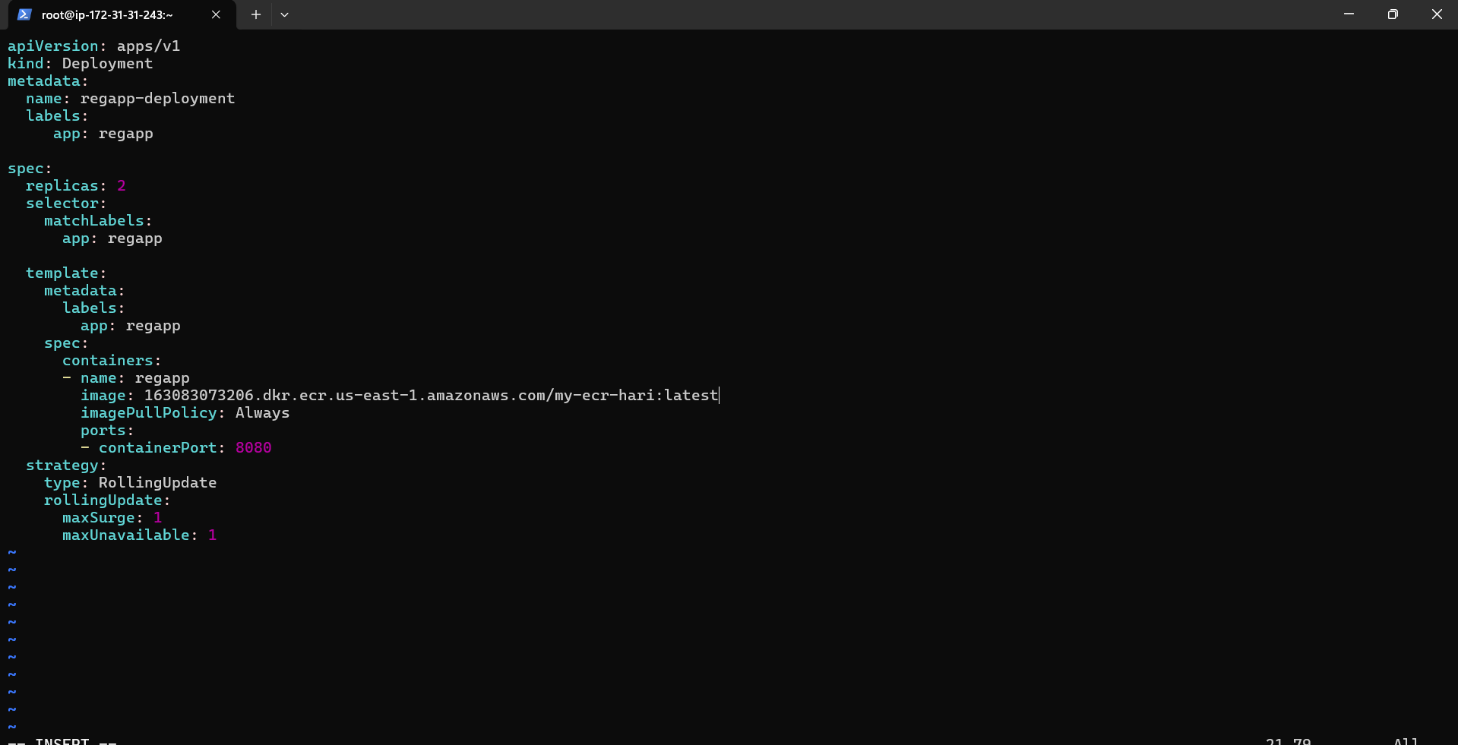

Deployment.yaml file is added with lates URI of the image.

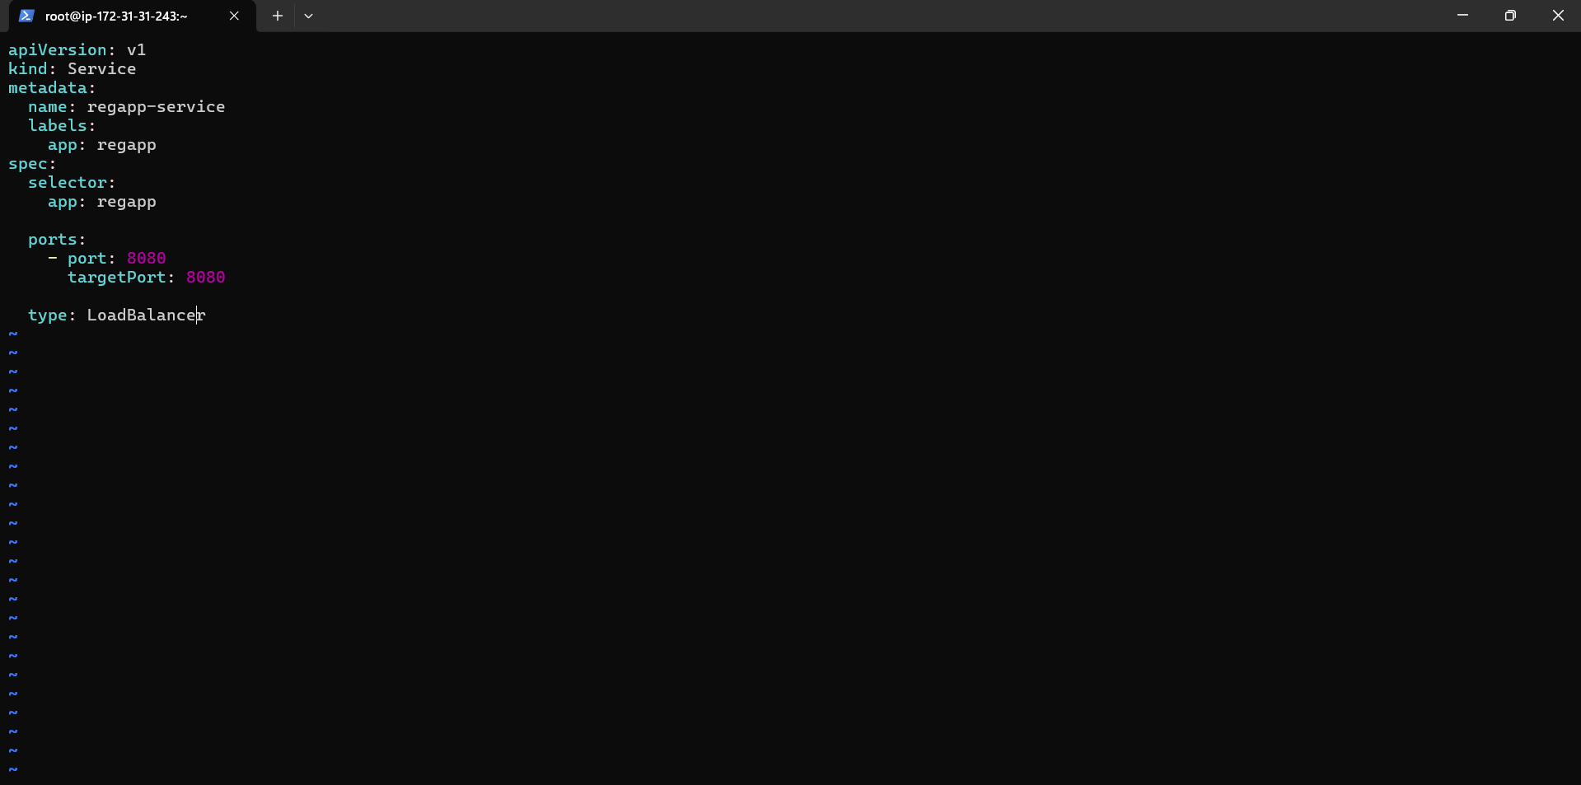

Service.yaml file is added with port enabled.

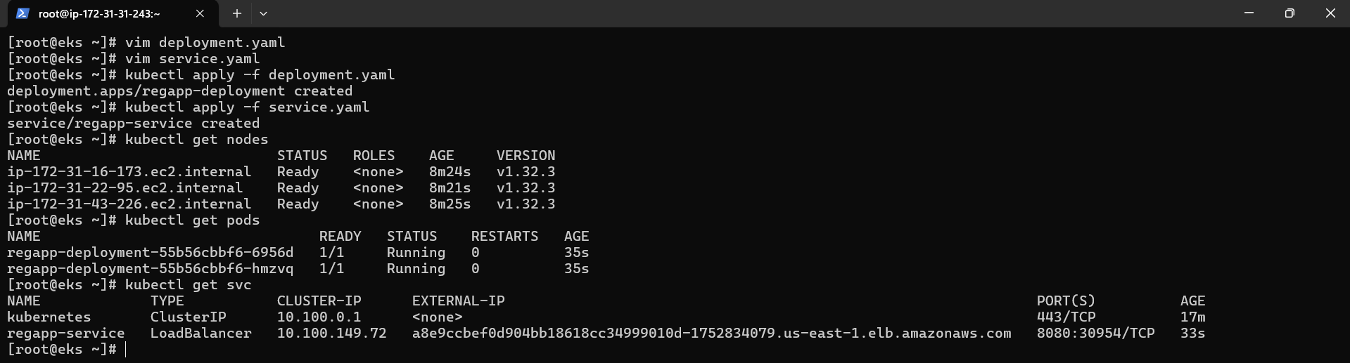

Both files are applied and pods, nodes are in running state. Using svc external ip is taken

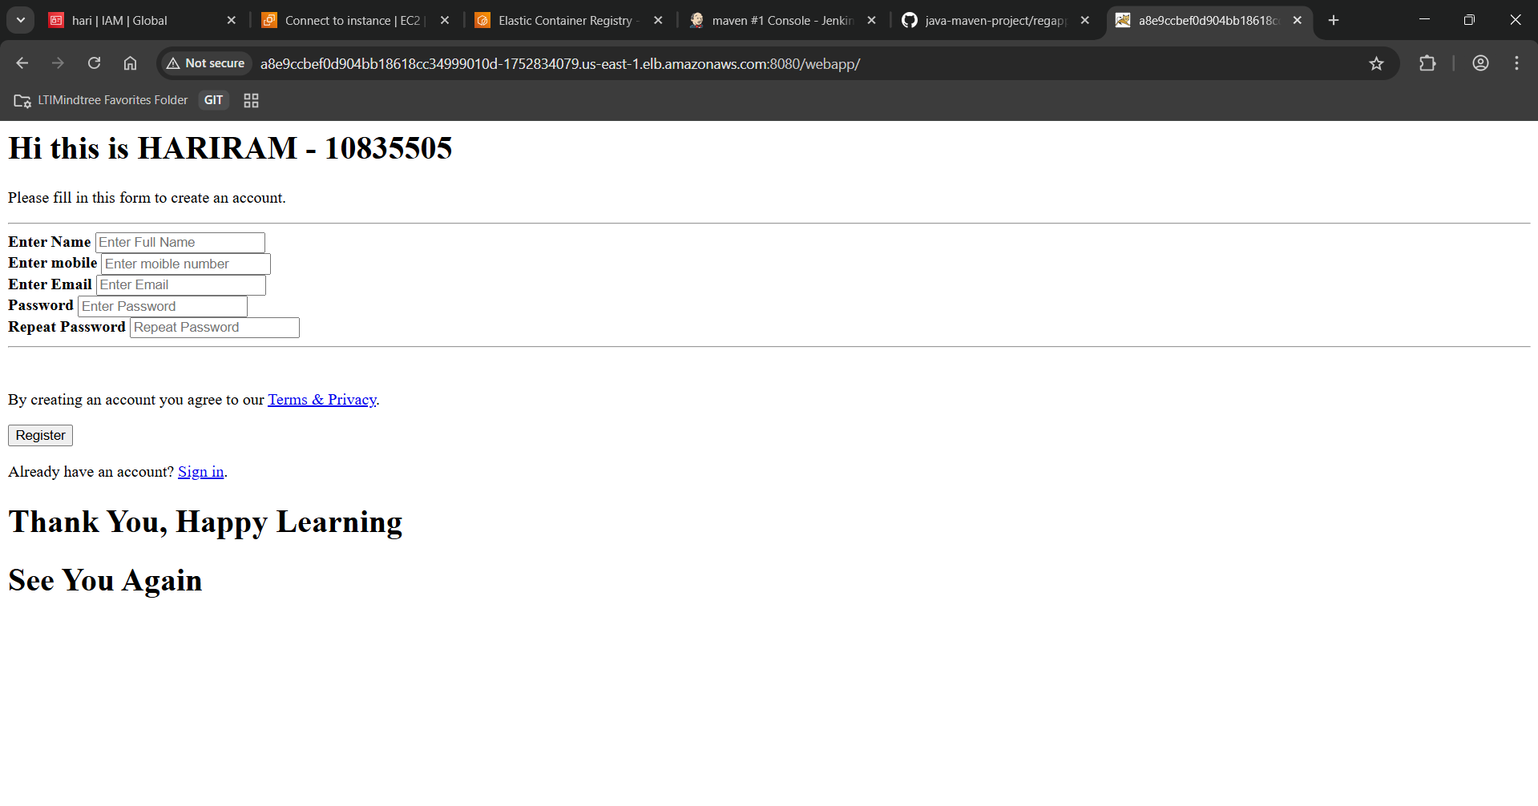

Finally maven project is deployed in live . External_ip:8080/webapp to access the webpage.